**Notes on data exploration (Kim)**

**1.0 Links**

**One drive from prior group**

[**https://drive.google.com/drive/folders/1-5MPViExf94efRjVpG7j6ng7lZKo1aHr**](https://drive.google.com/drive/folders/1-5MPViExf94efRjVpG7j6ng7lZKo1aHr)

**FAA**

<https://aspm.faa.gov>

<https://aspm.faa.gov/tfms/sys/Airport.asp>

<https://www.faa.gov/airports/planning_capacity/passenger_allcargo_stats/passenger/\>

<https://www.faa.gov/airports/planning_capacity/passenger_allcargo_stats/passenger/\>

[Airport Categories – Airports (faa.gov)](https://www.faa.gov/airports/planning_capacity/categories/)

<https://aspm.faa.gov/aspmhelp/index/Main_Page.html>

<https://www.faa.gov/mobile/index.cfm?event=office.regions>

[Visualize it: See FAA UAS Data on a Map (arcgis.com)](https://faa.maps.arcgis.com/apps/webappviewer/index.html?id=9c2e4406710048e19806ebf6a06754ad)

-**FAA airports Asset System- ranks airports, National airports usually have a tower**

<https://www.faa.gov/airports/planning_capacity/ga_study/>

**- FAA airport categories to find who they service**

[**https://www.faa.gov/airports/planning_capacity/categories/**](https://www.faa.gov/airports/planning_capacity/categories/)

-Joel Jenkinson, Airport Director of Addison (ADS) Dallas <https://addisontexas.net/airport> offered his assistance in the future should the group need it 972-392-4850. Kimberly Cawi had phone discussion 2-15-22 described below. [Joel.Jenkinson@addisonairport.net](mailto:Joel.Jenkinson@addisonairport.net)

<https://www.faa.gov/airports/planning_capacity/categories/>

**FAA-opsnet data: From group meeting 2/13/22: Sabi**

<https://aspm.faa.gov/opsnet/sys/Tower.asp>

**skybrary (used by prior group Summer 2021 Flightify 1.0, not useful for current project)**

<https://skybrary.aero/>

From old Flightify paper (just goes back to same page as <https://skybrary.aero/>

[**https://www.skybrary.aero/index.php**](https://www.skybrary.aero/index.php)

**How to download noaa data (the best source) – We are using This! \*\*\*\***

<https://www.google.com/url?sa=t&rct=j&q=&esrc=s&source=web&cd=&ved=2ahUKEwi5h-qBypH2AhXwj4kEHaq-CGMQFnoECAMQAw&url=https%3A%2F%2Fwww.ars.usda.gov%2FARSUserFiles%2F30980500%2FHowtoWeather2.docx&usg=AOvVaw2EgoOLVsgkGeDm2hTB6Ecu>

1. Go to <http://www.ncdc.noaa.gov/cdo-web/>
2. Click on the Search Tool.
3. Select Weather Observation Type/Dataset and select **Daily Summaries.**
4. Select Date Range using the calendar button (*Be sure to get daily weather data for 365/366 days of the year*).
5. Search for and choose the appropriate search type you will be using (typically we select **Stations).**
6. Enter a Search Term.
7. Click the **Search** button.

Now you should see a map of possible stations. You can navigate this just like Google Maps. Click on a square blue radio tower to see a summary of the station’s available data. The details show the **Latitude/Longitude** and the time **Period** they have weather data. Choose a site with as close to 100% **Coverage** to have the least amount of holes in your data. You can also click on the Full Details button or the station name on the left site of the screen to connect you to additional details of the station’s data.

1. Select a specific weather station by clicking on the orange **Add** or **Add to Cart** button depending on which method you used to find the station.
2. Click the orange **Cart** when you have added the station you want.
3. Review your Cart to make sure that the date range and stations name are what you selected.
4. Select the Output Format click on **Custom GHCN-Daily CSV.**
5. Click **Continue.**
6. Select the features you wish to receive.
7. Click **Continue.**
8. Enter email address and verify email address.
9. Click **Submit Order**.
10. You will receive an email saying that you requested data and another one saying the request is complete.
11. Click on the link at the top in the green box or the download data link, and save.
12. Open with EXCEL and format the data as shown below.

Step 8 Screen shot:

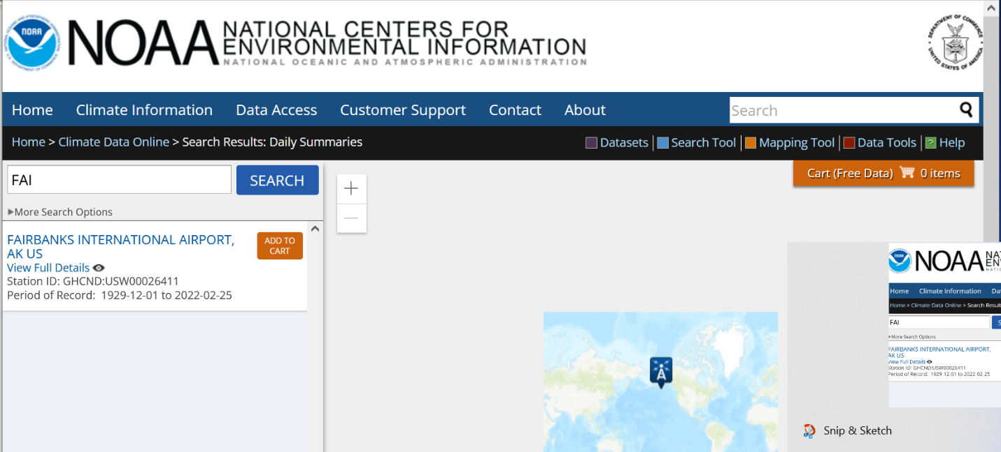  
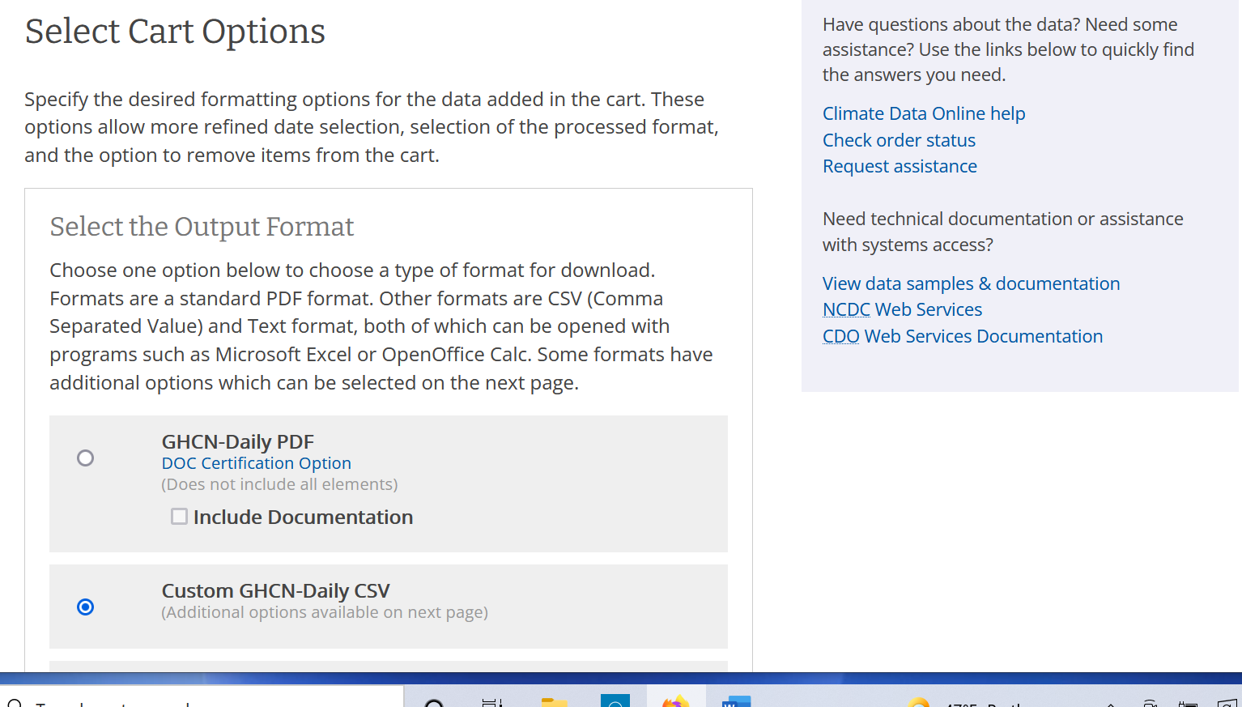

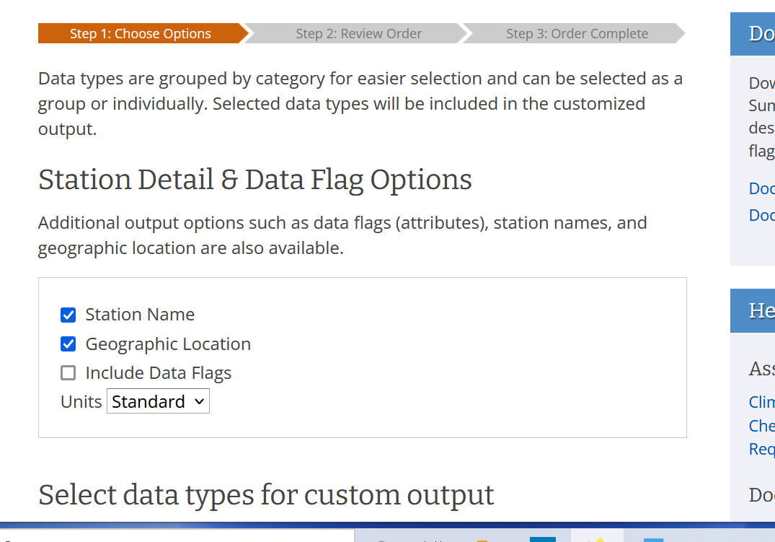

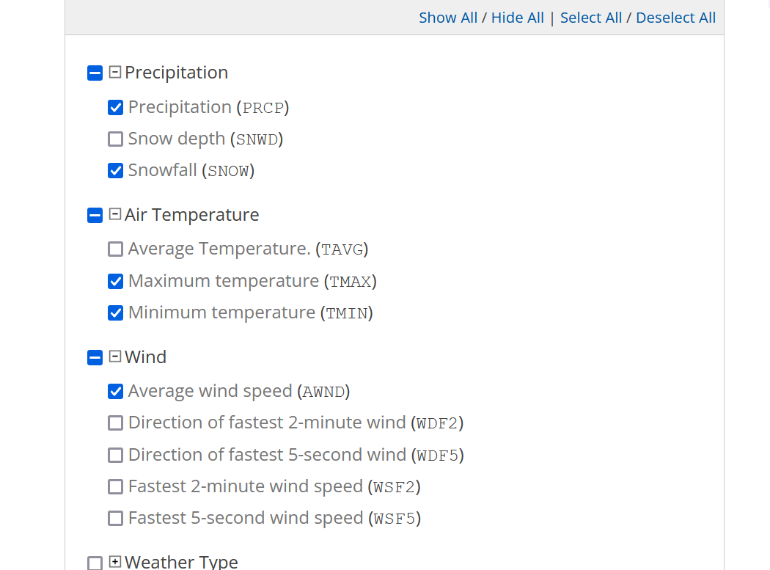

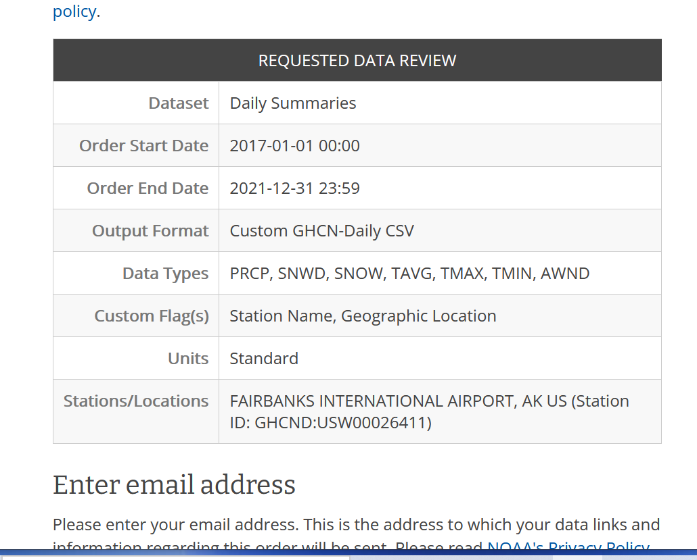

Top of Form

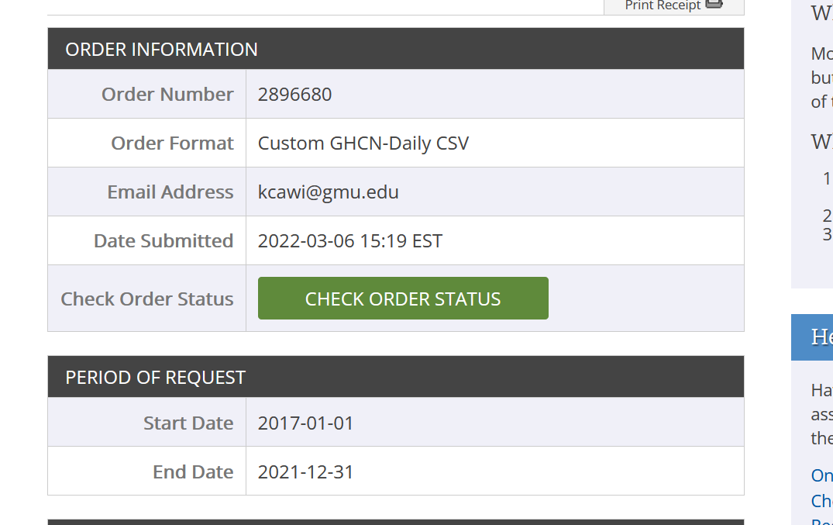

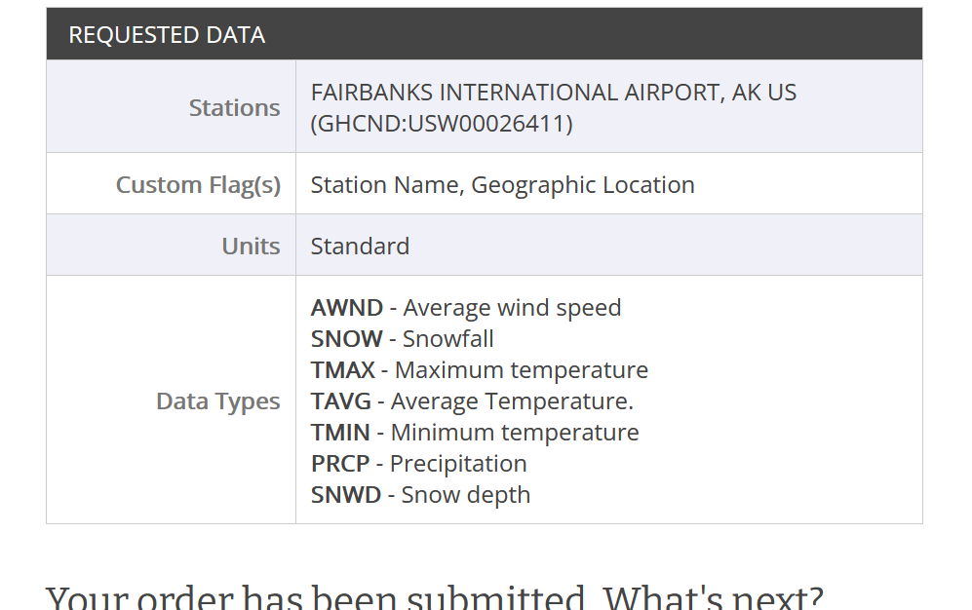

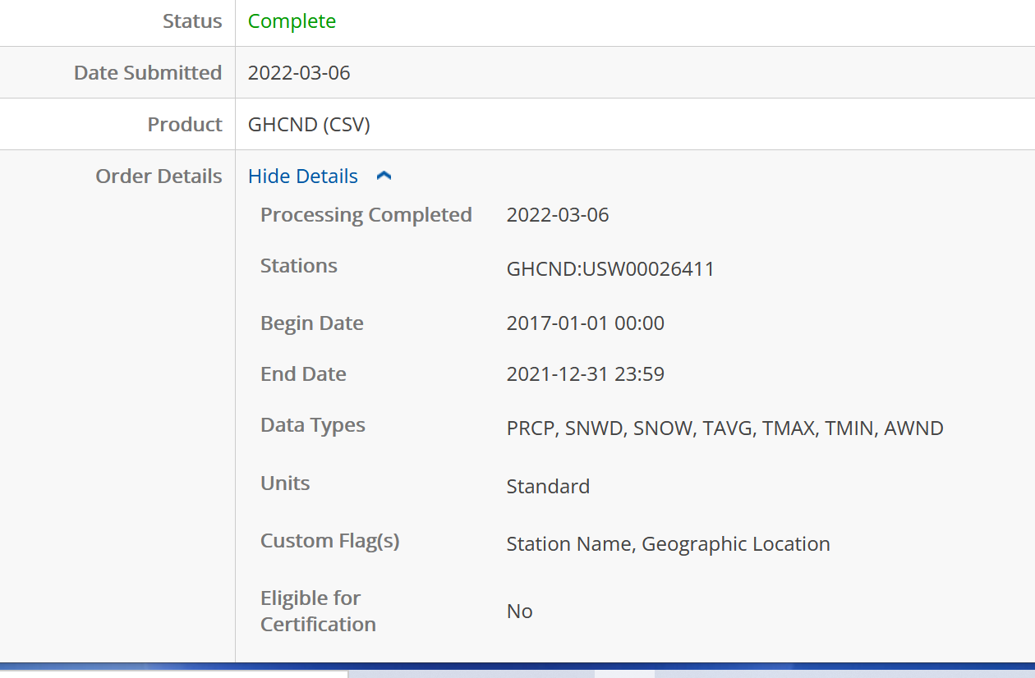

For noaa Daily Summaries Data set citation

[https://www.ncei.noaa.gov/metadata/geoportal/rest/metadata/item/gov.noaa.ncdc:C00861/html#](https://www.ncei.noaa.gov/metadata/geoportal/rest/metadata/item/gov.noaa.ncdc:C00861/html)

* Cite as: Menne, Matthew J., Imke Durre, Bryant Korzeniewski, Shelley McNeill, Kristy Thomas, Xungang Yin, Steven Anthony, Ron Ray, Russell S. Vose, Byron E.Gleason, and Tamara G. Houston (2012): Global Historical Climatology Network - Daily (GHCN-Daily), Version 3. [indicate subset used]. NOAA National Climatic Data Center. doi:10.7289/V5D21VHZ [access date].
* Publications citing this dataset should also cite the following article: Matthew J. Menne, Imke Durre, Russell S. Vose, Byron E. Gleason, and Tamara G. Houston, 2012: An Overview of the Global Historical Climatology Network-Daily Database. J. Atmos. Oceanic Technol., 29, 897-910. doi:10.1175/JTECH-D-11-00103.1.

**Noaa Time Stamp**

<https://www.nws.noaa.gov/mdl/forecast/graphics/common/time.html>

**Onestop access to noaa data (Not as useful, not using)**

<https://data.noaa.gov/onestop/collections?q=%22NOAA%20Climate%20Data%20Record%22>

**other noaa links**

<https://www.ncei.noaa.gov/>

<https://www.ncdc.noaa.gov/cdo-web/datatools/records>

<https://www.ncei.noaa.gov/products/climate-data-records/precipitation-gpcp-daily>

<https://www.ncdc.noaa.gov/cdo-web/webservices>

**2.0 Search path for data from old Summer 21 Flightify and discovery of hidden CountOps database**

**CountOps Reports help**

<https://aspm.faa.gov/aspmhelp/index/CountOps_Reports.html>

says “CountOps data can be viewed on the [**FAA Operations & Performance Data**](http://aspm.faa.gov/) Web site.”

Which is <https://aspm.faa.gov/> but CountOps Reports is not listed as an option.

**Countops Reports Manual help**

<https://aspm.faa.gov/aspmhelp/index/CountOps_Manual.html>

**Countops detail report help**

We want this report

<https://aspm.faa.gov/aspmhelp/index/CountOps__Detail_Report.html>

<https://aspm.faa.gov/aspmhelp/index/CountOps__Definitions_of_Variables.html>

Basically, we need to have CountOps as an option under this screen

<https://aspm.faa.gov/aspmhelp/images/7/7d/CountOps_Main.jpg>

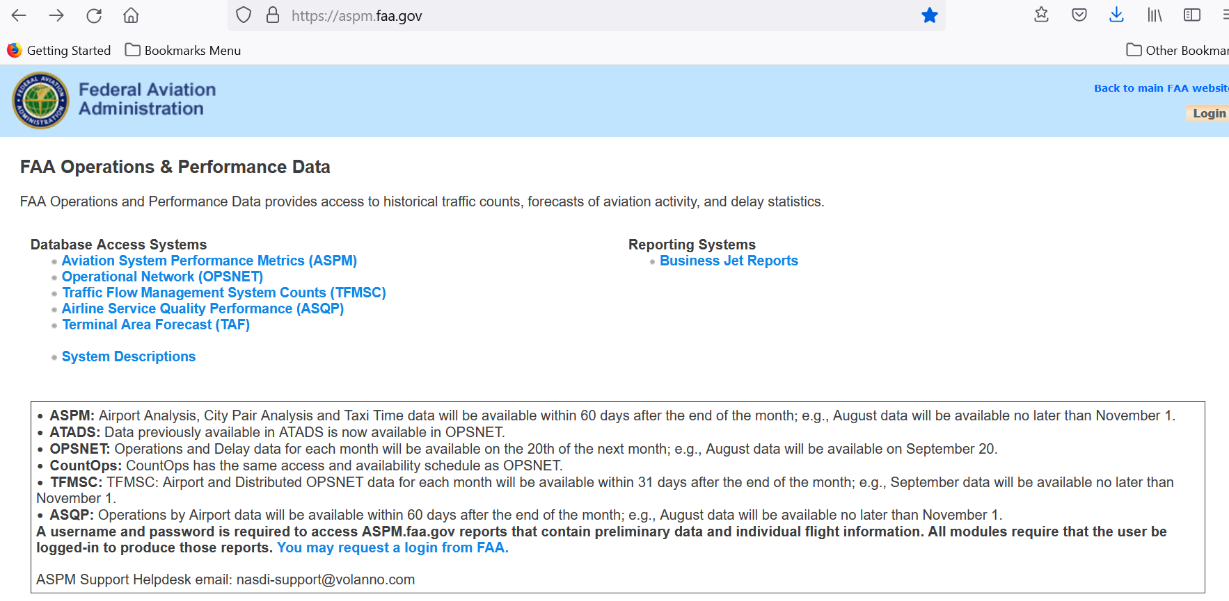

So we can get to this screen: <https://aspm.faa.gov/aspmhelp/images/7/7d/CountOps_Main.jpg>

It turns out that it CountOps database is not publicly available and was accessed by an internal pull by the FAA, then provided to the Summer 2021 students.

**2.1 Data Codes mapping**

From Jared’s original old Flightify data folder, flightify_except_data

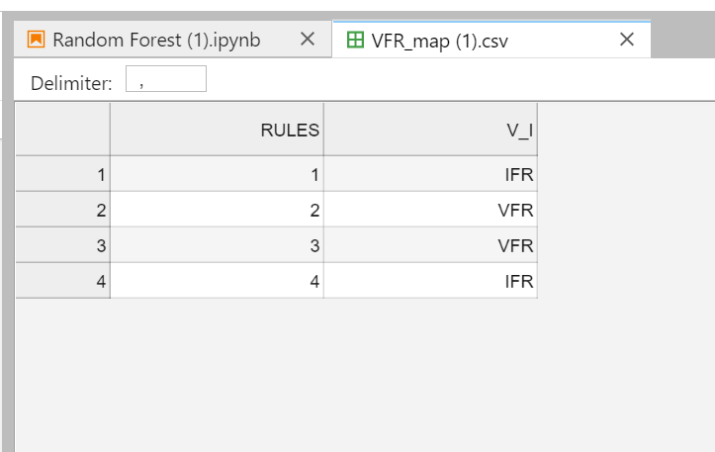

In the file, One Hot Encode.ipyn, the rules are merged into IFR, VFR.

# combine

df = df.merge(VFR_Map, on = 'RULES', how = 'outer')

df

**3.0 Choosing 500 Airports**

Per Partner meeting 2/18/22

* We are to find airports within 9 regions looking for a target 50/50 IFR/VFR Split and high IFR.

**3.1 Phone Call with ADS Dallas airport Director, Joel Jenkinson 2/15/22**

**-Joel Jenkinson, Airport Director of Addison (ADS) Dallas** [**https://addisontexas.net/airport**](https://addisontexas.net/airport) **offered his assistance in the future should the group need it 972-392-4850 airport number, 972-392-4855 direct number.** [**Joel.Jenkinson@addisonairport.net**](mailto:Joel.Jenkinson@addisonairport.net)

2-15-22 I Called Addison (ADS) Dallas airport <https://addisontexas.net/airport> , a premier General Aviation Airport near Dallas, TX, and talked with Joel Jenkinson, the airport director: (30 minutes)

-Reason for call: To get ideas of choosing airports for project and to get a quick answer to whether Airports: Advanced search Type: VFR Tower filter means the airport is exclusively for VFR. The answer is no. They do 40% IFR traffic. They receive be training aircraft to large corporate jets.

-ADS is a general aviation airport and under Airports: Advanced Search: Foreign: No , US Tower: yes, Type: VFR Tower

-However, ADS airport has 40% IFR airplanes coming in. VFR Tower does not mean only VFR traffic. It is not exclusive. ADS has a tower. It is not a radar tower. They get the radar feed from somewhere else.

-Joel Jenkinson -Shared explanations:

IFR scenario: Leave airport tower control, get handed to TRACON, in route pass through CENTERS (big area above 18,000 ft), handed to TRACON, handed to airport tower.

GA= not airline or military, can be training aircraft to large corporate jet (definition according to Joel Jenkinson)

500 major airports

-He suggested: Try looking up FAA airports Asset System- ranks airports, National airports usually have a tower

<https://www.faa.gov/airports/planning_capacity/ga_study/>

-try faa.gov/airports/categories or FAA airport categories to find who they service

<https://www.faa.gov/airports/planning_capacity/categories/>

**-Joel Jenkinson, Airport Director of Addison (ADS) Dallas** [**https://addisontexas.net/airport**](https://addisontexas.net/airport) **offered his assistance in the future should the group need it 972-392-4850 airport number, 972-392-4855 direct number.** [**Joel.Jenkinson@addisonairport.net**](mailto:Joel.Jenkinson@addisonairport.net)

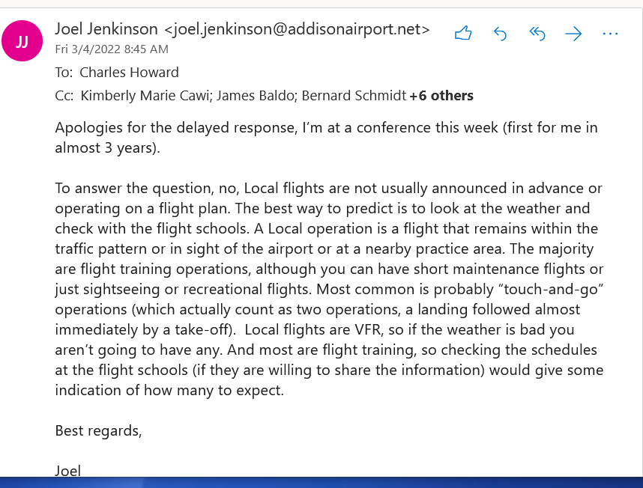

**3.2 Airport Categories**

<https://www.faa.gov/airports/planning_capacity/categories/>

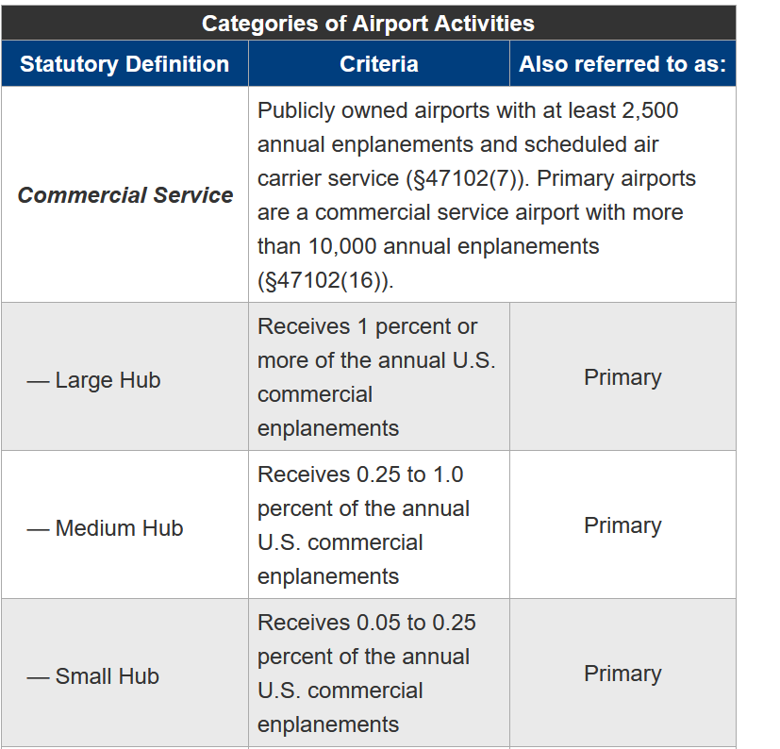

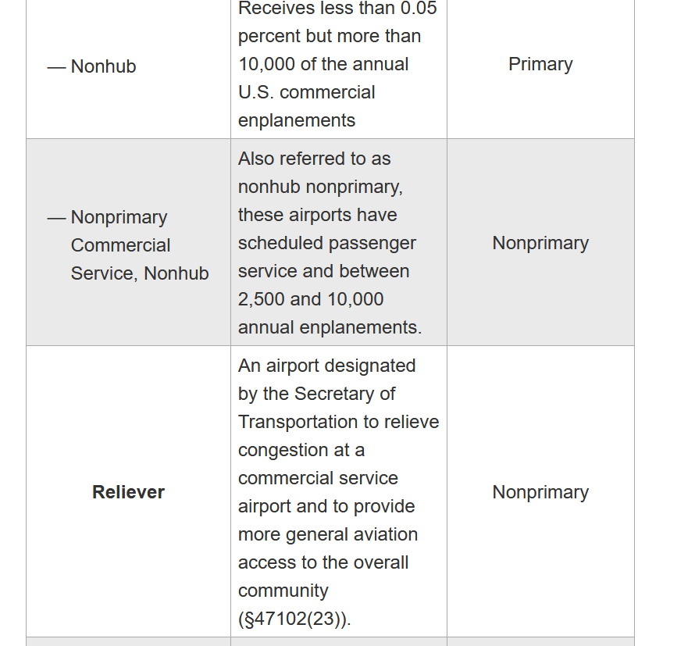

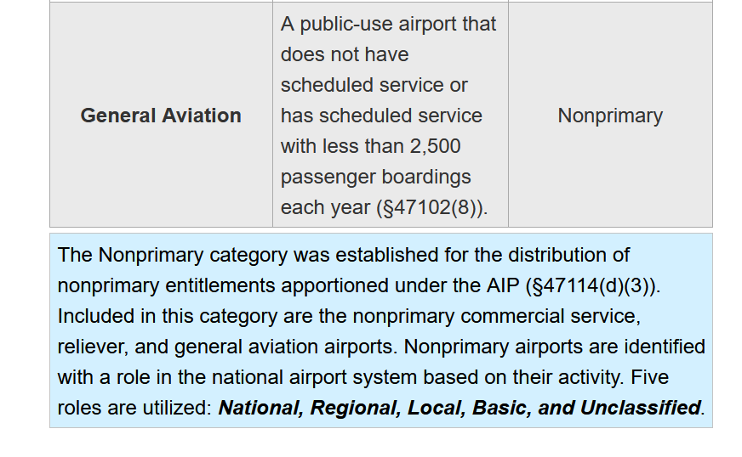

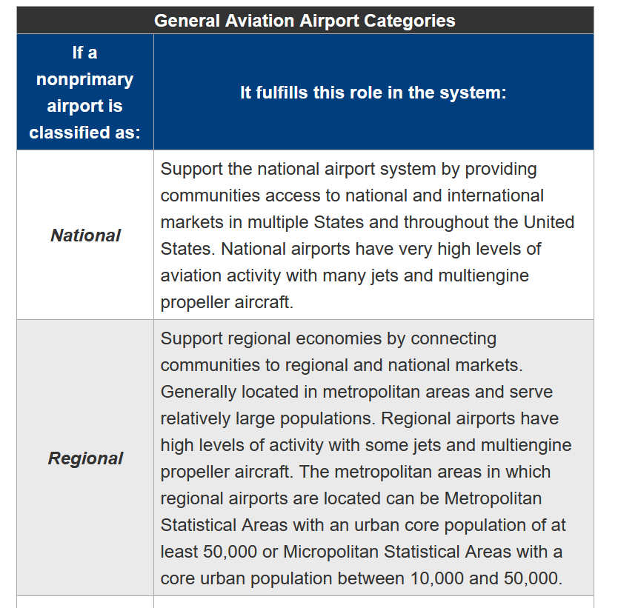

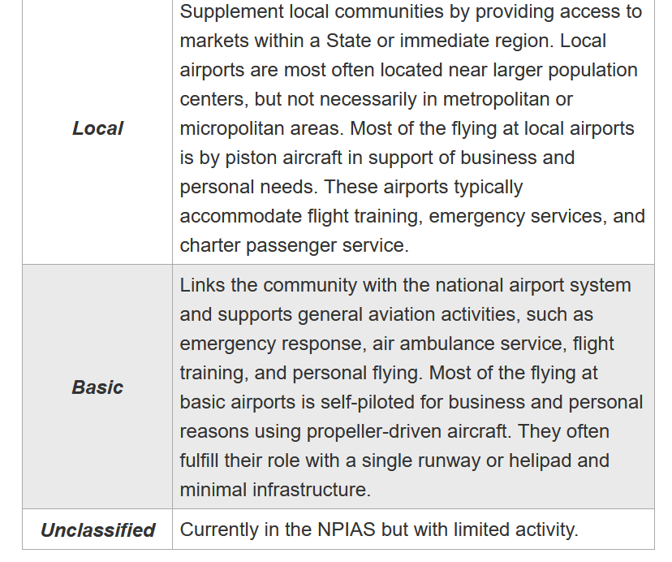

**4.0 Old Flightify paper notes from prior group**

Sect 2.3 – 942

“ unique aircrafts categorical descriptions manually entered by researching skybrary and other sources. “

“There was an initial assumption that weather would have a large impact on the model, but because weather is unreliable the further it is predicted out and due to concerns about biasing the model, it was taken out of consideration.

“There was an initial assumption that weather would have a large impact on the model, but because weather is unreliable the further it is predicted out and due to concerns about biasing the model, it was taken out of consideration.”

(Kim) Agree that long range predictions based on weather is not good. But VFR flights go/no go decisions are all about weather. If it is predicted poorly, then they cancel airplane events and flights even if weather later improves.

“The Aircraft Mapping dataset lists the aircraft type, the type ID, aircraft body type, aircraft wing type, the wake turbulence category, aircraft type code, engine type, and engine count.”

Sect 2.4

“Datasets provided by the FAA were given in separate csv files for each year, and each file contained a grouping of airports. In total, there were 15 traffic flow management data files”

“The team manually curated a dataset (described in detail above) to map on to the “Aircraft Type” variable in the TFMS data that provided attributes about each aircraft. This both added context to the data and aggregated the aircraft types from over 900 unique variables to easily analyzed categories. “

(Kim) I think they mean 900 unique aircraft in the type variable.

“ As a result, the team decided to one-hot encode features such as the body type, wing type, engine, engine count, and more. This increased the size of the dataset and expanded the columns from 9 to 46, posing processing issues during analysis.”

(Kim) I don’t think we need to one hot encode if we use random forest and other algorithms accepting categorical data. Plus I question using these variables and this method as a whole for forecasting, since it won’t predict future traffic since we can’t possibly know the attributes until the plane is in contact with air traffic control. Under current investigation.

Lastly, the FAA was interested in understanding the impact of time of day, time of year, and special events. To add these items into the dataset, the team parsed the date and time fields. The TFMS dataset holds date as YYYYMMDD and it was parsed to three individual columns: year, month, and day. Similarly, the time field, HHMM, was used to create morning, afternoon, and evening columns. To begin to explore the impact of special events on air traffic, the team assigned a binary column (“Special_Event”) on regular holidays each year inside of Tableau directly. For example, Thanksgiving, Christmas, New Years Day, and Memorial Day were all included as special event days. Also, the team aggregated the column that hosted whether or not a flight was using VFR or IFR to simply say “VFR” or “IFR” rather than specific variations of the two. This was done because the FAA indicated that, for this purpose, the variations were not valuable.

**5.0 Helpful definitions:**

overflight operations:

<https://www.faa.gov/air_traffic/publications/atpubs/foa_html/chap13_section_4.html>

“

1. “TABULATION
2. Count IFR overflight operations as follows: One count for each segment of flight when an aircraft on an IFR flight plan or SVFR clearance transits the airspace. A TRACON that hands an aircraft off to the tower and the aircraft returns to the TRACON, count the additional portion as a separate segment.
3. Count VFR overflight operations as follows:   
   One count for each segment when an aircraft operating VFR transits the airspace. A TRACON that hands an aircraft off to the tower and the aircraft returns to the TRACON, count the additional portion as a separate segment.

“

Itinerant Operations:

<https://www.faa.gov/air_traffic/publications/atpubs/foa_html/chap13_section_2.html>

1. TABULATION
2. Count IFR itinerant operations as follows:
3. One count for an aircraft on an IFR flight plan or a special visual flight rule (SVFR) clearance that:
4. Takes off.
5. Lands.
6. One count for aircraft on an IFR flight plan that executes a missed approach procedure.
7. One count for a VFR aircraft that requests to practice the published missed approach procedure when approved separation is provided by the tower and TRACON.
8. One count for a SVFR clearance operating wholly within the Class D or Class E surface area, e.g., local SVFR making a series of landings and takeoffs (towers).

NOTE-

When an aircraft operates on a SVFR clearance for a series of VFR patterns and landings, only one instrument count must be taken for the SVFR clearance, while each takeoff and landing is tabulated as a local operation.

1. One count for each aircraft practicing instrument procedures either on an IFR flight plan or VFR (if approved separation is provided) that:
2. Takes off from a complete stop and practices an instrument departure.
3. Practices an instrument approach procedure.
4. Count VFR itinerant operations as follows:
5. One count for an aircraft operating VFR that:
6. Takes off.
7. Lands.
8. Two counts for each low approach below traffic pattern altitude (one landing and one taking off), a stop and go operation, or touch-and-go operation.

NOTE-

**6.0 important emails**

**From Jared** Mon 2/14/2022 11:25 AM

Sent flightify except data.zip

Teeter, Jared P (FAA) <Jared.P.Teeter@faa.gov>

Mon 2/14/2022 11:32 AM

Sent flightify_data_year2021.zip

**From Jared** Fri 2/18/2022 4:02 PM

I have uploaded FAI CountOps report for the timeframe 2017 to 2021. Because I aimed to download the data as quickly as possible the last day in the Excel file name will also show up in the first day of the following Excel file name. For example, 20170301 (March 1st, 2017) shows up twice. First in the file *fai_20170101_to_20170301.xlsx* and then secondly in the file *fai_20170301_to_20170501.xlsx*.

(Kim note: he means CountOps Detail report)

**Alec**

Fri 2/18/2022 10:15 AM

Hello again,

Just wanted to provide a correction to my previous email.

**We have data from Jan 1 - Dec 31 for the following datasets:**

data_FAI_AUS_AGS_2017 - 2020

data_MDW_MCO_2017 - 2020

**We have data from Jan 1 - June 1 for the following datasets:**

data_FAI_AUS_AGS_2021

data_MDW_MCO_2021

data_TEB_SLC_LAS_2017 - 2021



Alec W Gray

Fri 3/11/2022 6:14 PM

Hey Team,

Per our discussion earlier, I wanted to follow up with the required naming conventions for both FAA and NOAA downloaded datasets. Below you will see the required format followed by an example. Please let me know if you have any questions.

------------------------------------------------------------------------------------------------------------------------------------------

FAA OPSNET Tower Operations Naming Convention

**Template**: [airport id code]_opsnet_tower_ops_2017-2021.csv

**Example**: fai_opsnet_tower_ops_2017-2021.csv

NOAA Naming Convention

**Template**: [airport id code]_[station code]_2017-2021.csv

**Example**: fai_noaa_usw00026451_2017-2021.csv

-------------------------------------------------------------------------------------------------------------------------------

**7.0 Pilot, and maintenance schools**

<https://www.faa.gov/training_testing/schools/>

<https://av-info.faa.gov/PilotSchool.asp>

<https://av-info.faa.gov/MaintenanceSchool.asp>

---------------------------------------------------------------------------------------------------------------------

**8.0 OPSNET TOWEROPS Data**

**Procedure to download TowerOps data -THIS IS WHAT WE ARE USING**

**See screen shots below and the link** <https://aspm.faa.gov>

<https://aspm.faa.gov>

This link below describes a report comparing CountOps and OPSNET Tower Comparison numbers to show how they were trying to validate the numbers

https://aspm.faa.gov/aspmhelp/index/CountOps__CountOps/OPSNET_Tower_Comparison_Report.html

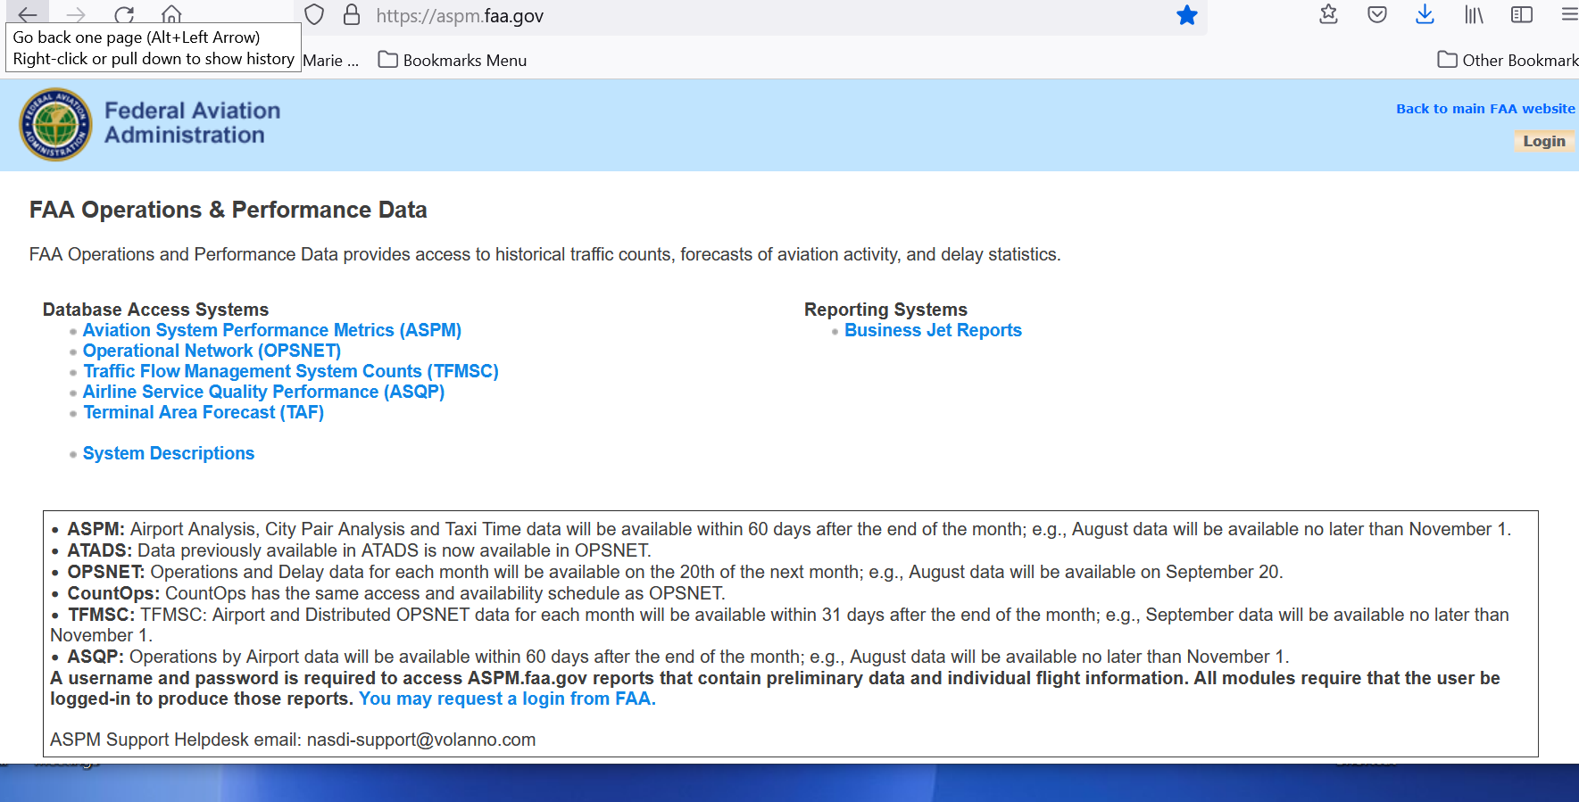

Choose OPSNET

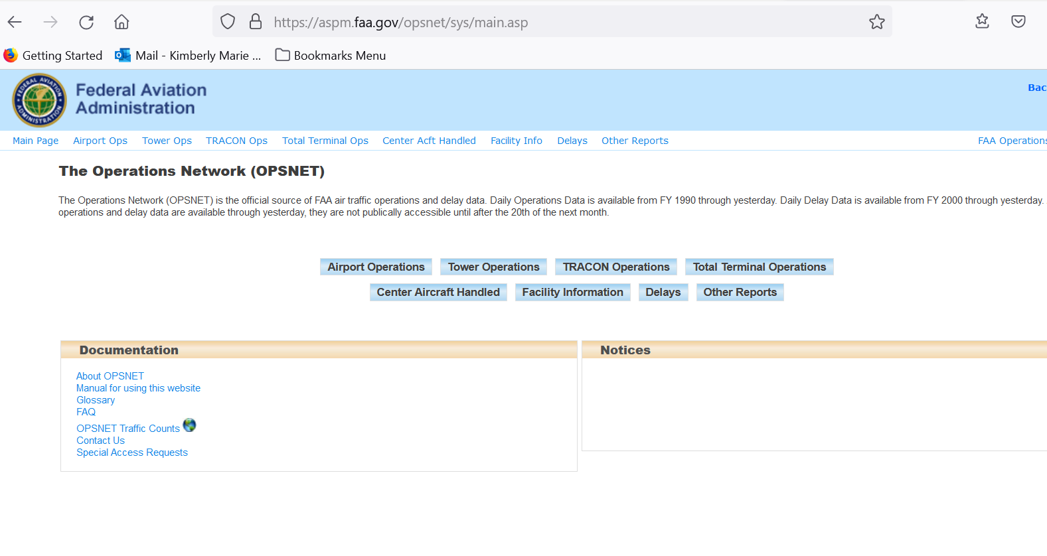

Choose tower Operations

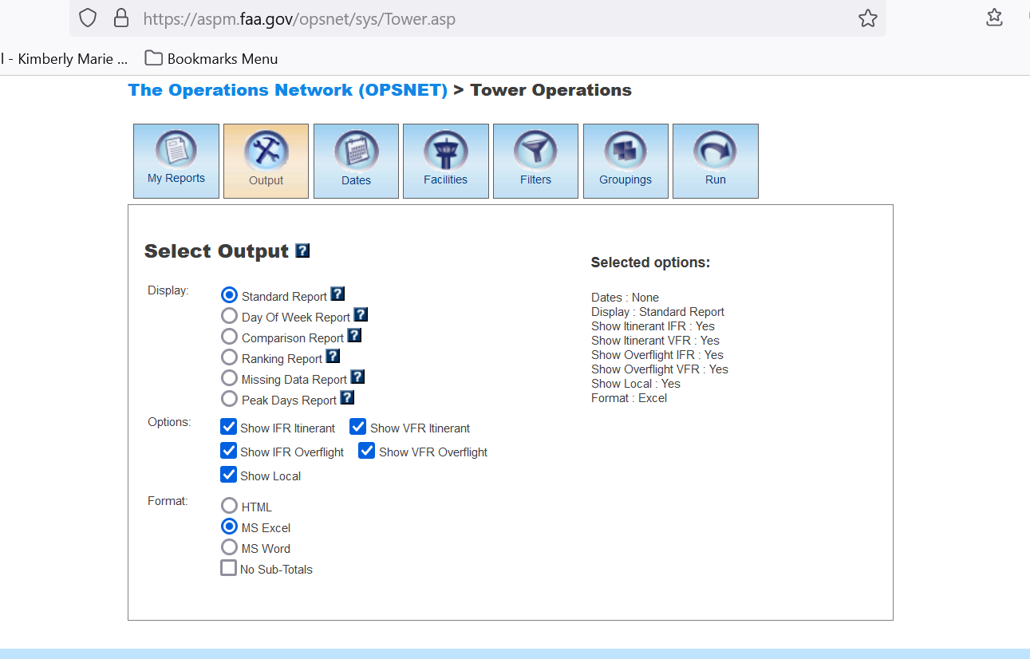

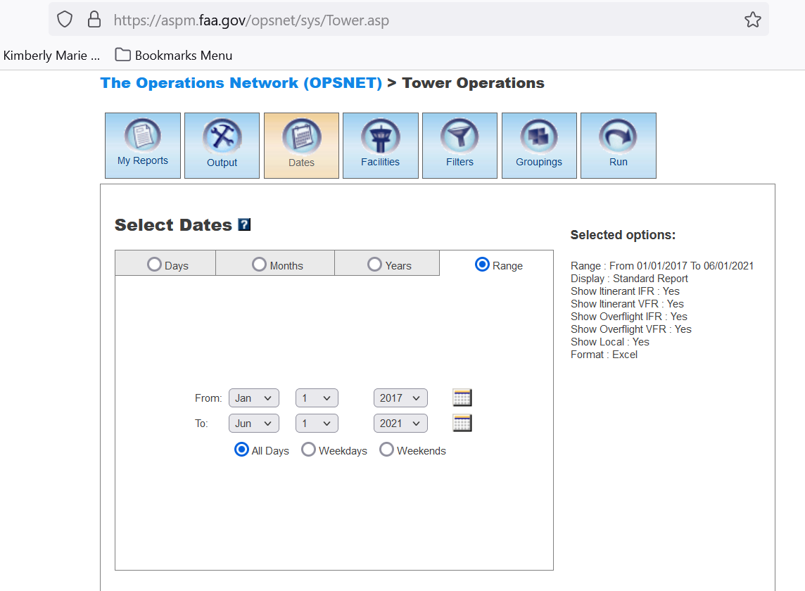

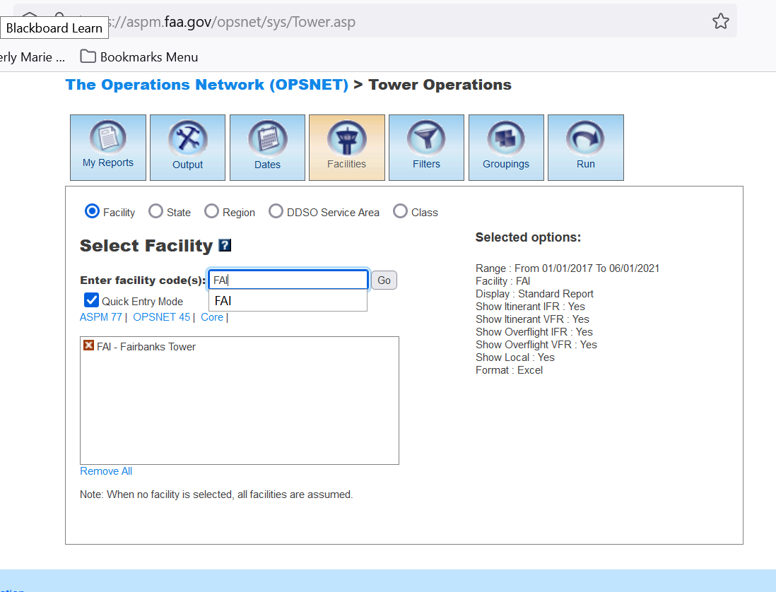

Enter Airport and click Go

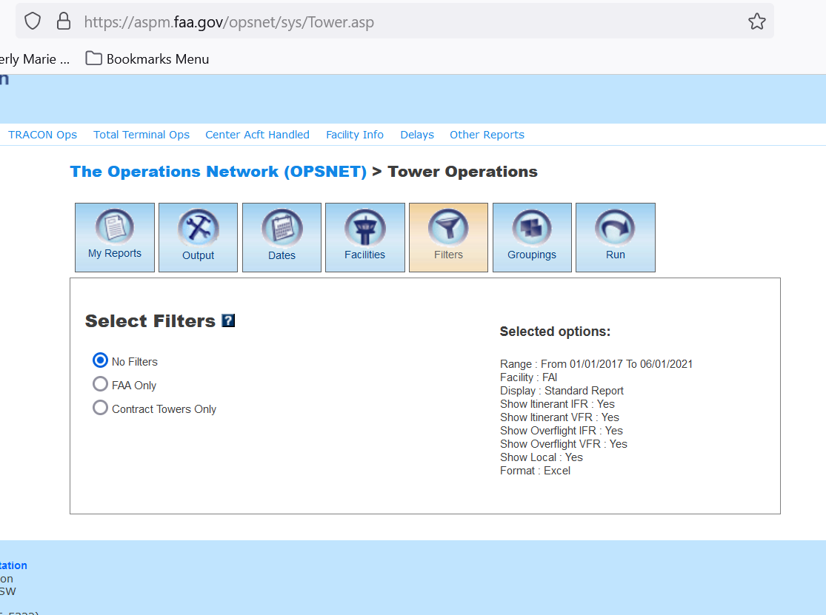

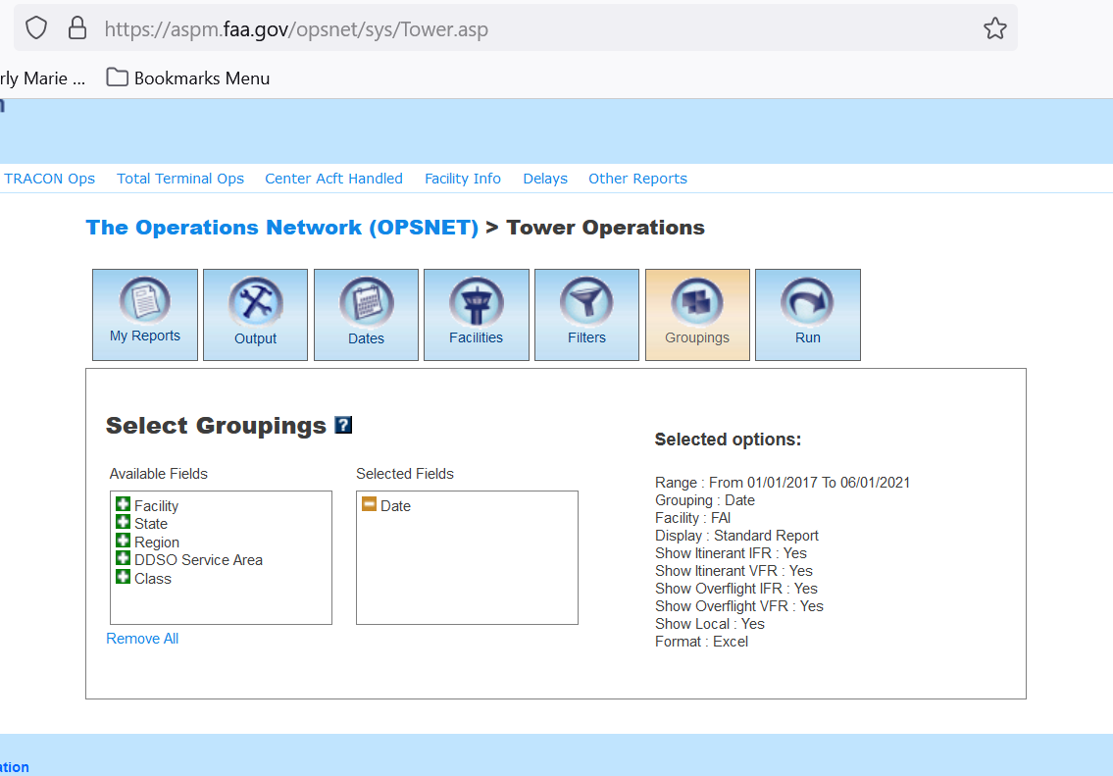

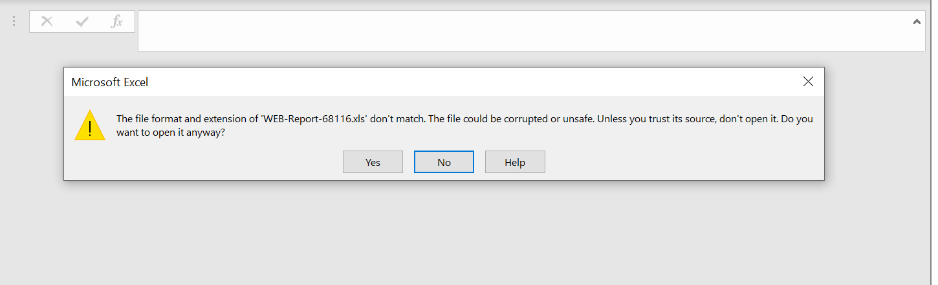

Say yes

# OPSNET Reports: Definitions of Variables

<https://aspm.faa.gov/aspmhelp/index/OPSNET_Reports__Definitions_of_Variables.html>

# OPSNET Manual

<https://aspm.faa.gov/aspmhelp/index/OPSNET_Manual.html#Definitions_of_Variables>

**Forecast Data Possibilities: links for sources and code examples**

**-------------------------------------------------------------------------------------------------------**

------------------------------------------------------------------------------------------------------------------------------------

**9.0 Weather Data**

**\*\*\*\***

**National Oceanic and Atmospheric Administration’s National Weather Service**

# National Digital Forecast Database (NDFD) Simple Object Access Protocol (SOAP) Web Service

<https://graphical.weather.gov/xml/>

Note: This works very well as a manual pull. Matches our attributes for our historical data from Noaa. Downside is it has sporadic number of days in the forecast. One variable may have 4 days another 6, and others 7 or 8.

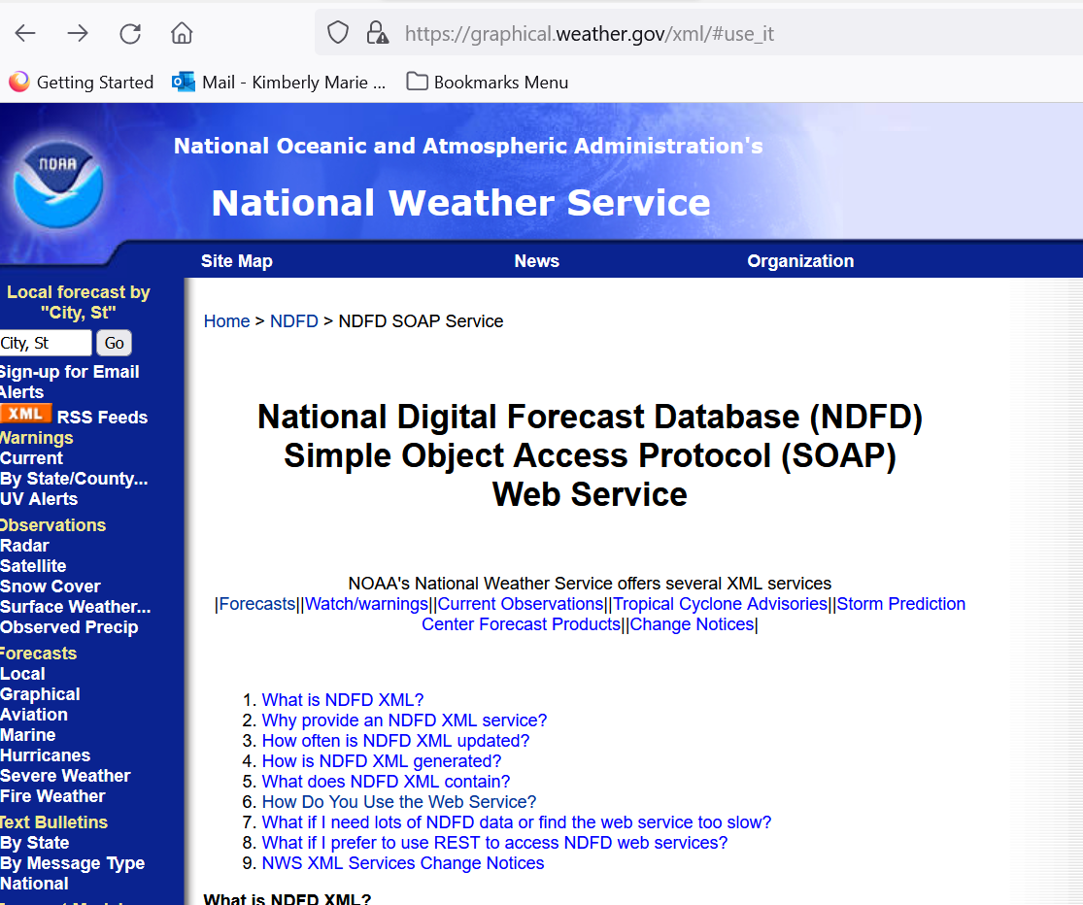

Choose option 6

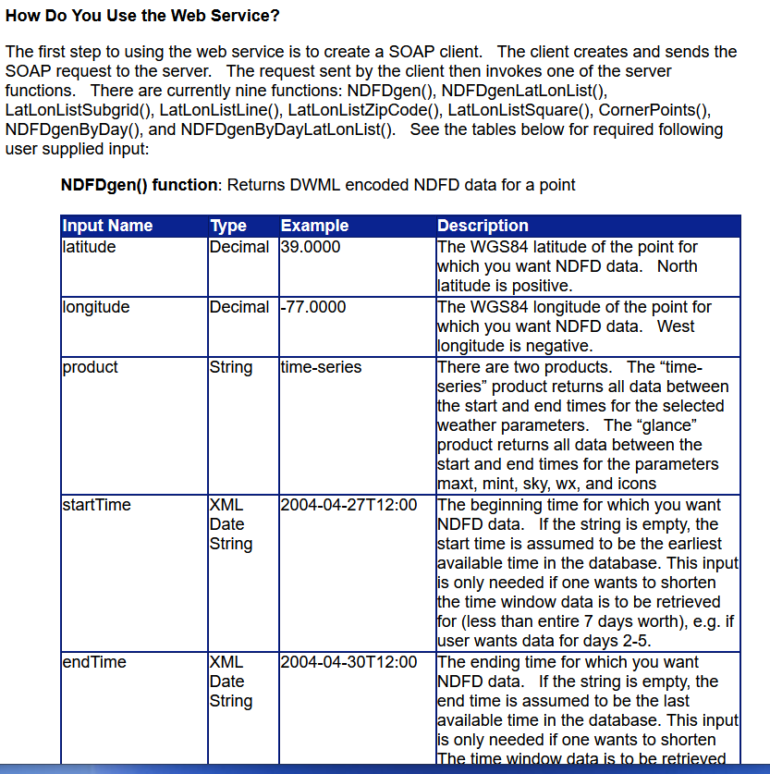

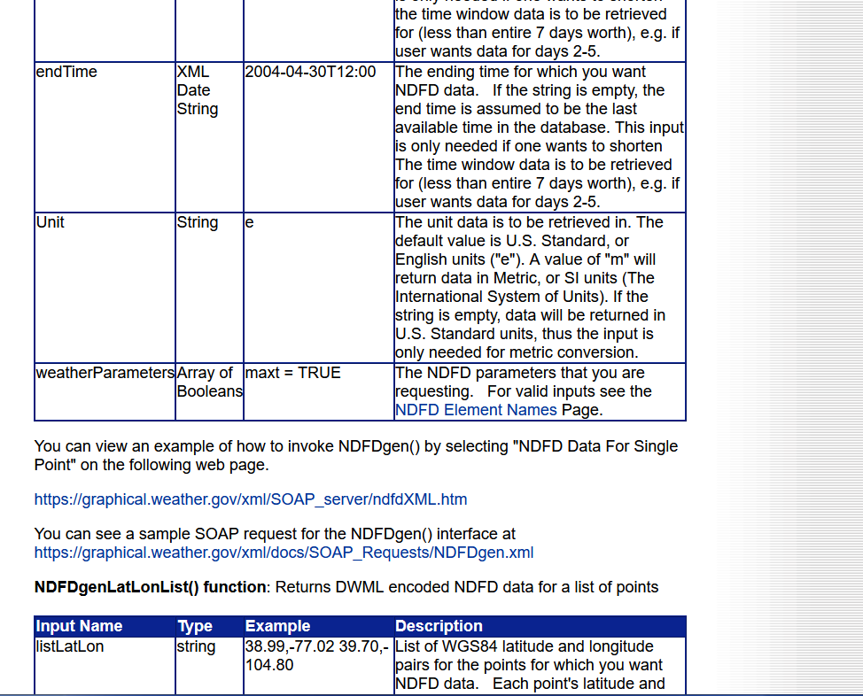

### Click on

### the “NDFD Element names” page for list of weather attributes to choose from.

### It actually takes you here: National Digital Forecast Database XML Web Service Forecast Element Names

<https://graphical.weather.gov/xml/docs/elementInputNames.php>

Then choose this:

You can view an example of how to invoke NDFDgen() by selecting "NDFD Data For Single Point" on the following web page.

<https://graphical.weather.gov/xml/SOAP_server/ndfdXML.htm>

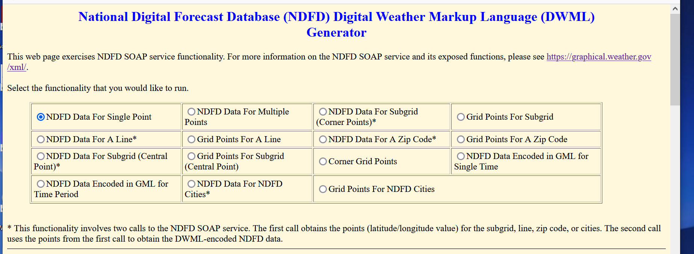

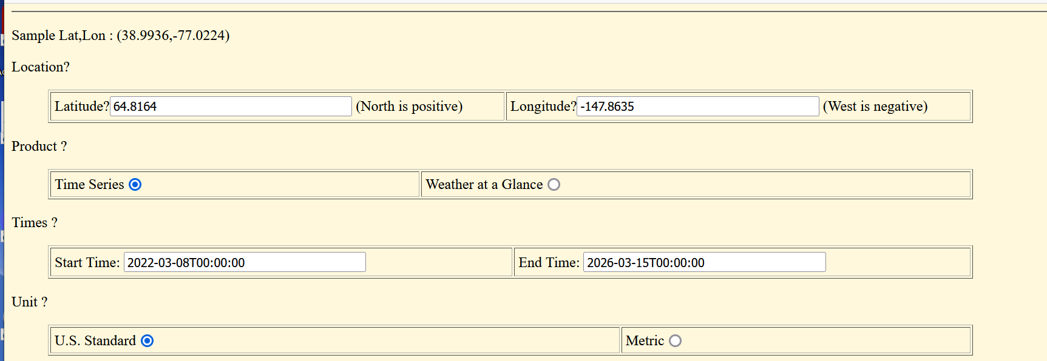

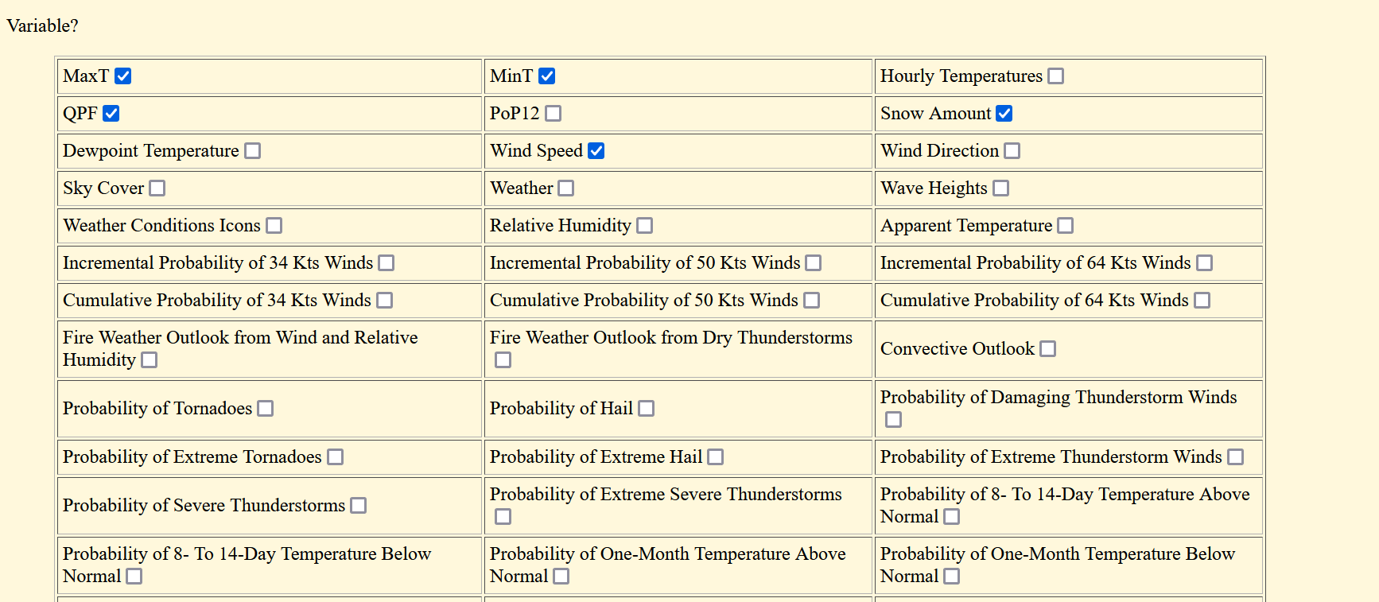

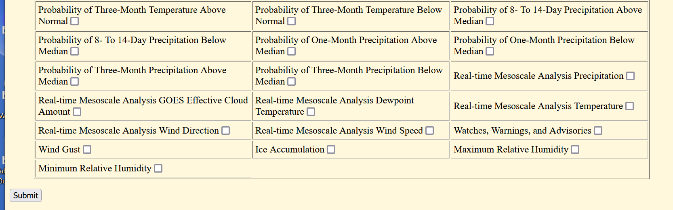

Click Submit

Produces the following Output

This XML file does not appear to have any style information associated with it. The document tree is shown below.

<dwml version="1.0" xsi:noNamespaceSchemaLocation="https://graphical.weather.gov/xml/DWMLgen/schema/DWML.xsd">

<head>

<product srsName="WGS 1984" concise-name="time-series" operational-mode="official">

<title>NOAA's National Weather Service Forecast Data</title>

<field>meteorological</field>

<category>forecast</category>

<creation-date refresh-frequency="PT1H">2022-03-08T04:12:33Z</creation-date>

</product>

<source>

<more-information>https://graphical.weather.gov/xml/</more-information>

<production-center>

Meteorological Development Laboratory

<sub-center>Product Generation Branch</sub-center>

</production-center>

<disclaimer>http://www.nws.noaa.gov/disclaimer.html</disclaimer>

<credit>https://www.weather.gov/</credit>

<credit-logo>https://www.weather.gov/logorequest</credit-logo>

<feedback>https://www.weather.gov/contact</feedback>

</source>

</head>

<data>

<location>

<location-key>point1</location-key>

<point latitude="64.82" longitude="-147.86"/>

</location>

<moreWeatherInformation applicable-location="point1">

https://forecast-v3.weather.gov/point/64.82,-147.86

</moreWeatherInformation>

<time-layout time-coordinate="local" summarization="none">

<layout-key>k-p24h-n7-1</layout-key>

<start-valid-time>2022-03-08T07:00:00-09:00</start-valid-time>

<end-valid-time>2022-03-08T19:00:00-09:00</end-valid-time>

<start-valid-time>2022-03-09T07:00:00-09:00</start-valid-time>

<end-valid-time>2022-03-09T19:00:00-09:00</end-valid-time>

<start-valid-time>2022-03-10T07:00:00-09:00</start-valid-time>

<end-valid-time>2022-03-10T19:00:00-09:00</end-valid-time>

<start-valid-time>2022-03-11T07:00:00-09:00</start-valid-time>

<end-valid-time>2022-03-11T19:00:00-09:00</end-valid-time>

<start-valid-time>2022-03-12T07:00:00-09:00</start-valid-time>

<end-valid-time>2022-03-12T19:00:00-09:00</end-valid-time>

<start-valid-time>2022-03-13T08:00:00-08:00</start-valid-time>

<end-valid-time>2022-03-13T20:00:00-08:00</end-valid-time>

<start-valid-time>2022-03-14T08:00:00-08:00</start-valid-time>

<end-valid-time>2022-03-14T20:00:00-08:00</end-valid-time>

</time-layout>

<time-layout time-coordinate="local" summarization="none">

<layout-key>k-p24h-n7-2</layout-key>

<start-valid-time>2022-03-07T19:00:00-09:00</start-valid-time>

<end-valid-time>2022-03-08T08:00:00-09:00</end-valid-time>

<start-valid-time>2022-03-08T19:00:00-09:00</start-valid-time>

<end-valid-time>2022-03-09T08:00:00-09:00</end-valid-time>

<start-valid-time>2022-03-09T19:00:00-09:00</start-valid-time>

<end-valid-time>2022-03-10T08:00:00-09:00</end-valid-time>

<start-valid-time>2022-03-10T19:00:00-09:00</start-valid-time>

<end-valid-time>2022-03-11T08:00:00-09:00</end-valid-time>

<start-valid-time>2022-03-11T19:00:00-09:00</start-valid-time>

<end-valid-time>2022-03-12T08:00:00-09:00</end-valid-time>

<start-valid-time>2022-03-12T20:00:00-09:00</start-valid-time>

<end-valid-time>2022-03-13T09:00:00-08:00</end-valid-time>

<start-valid-time>2022-03-13T20:00:00-08:00</start-valid-time>

<end-valid-time>2022-03-14T09:00:00-08:00</end-valid-time>

</time-layout>

<time-layout time-coordinate="local" summarization="none">

<layout-key>k-p3h-n37-3</layout-key>

<start-valid-time>2022-03-08T03:00:00-09:00</start-valid-time>

<start-valid-time>2022-03-08T06:00:00-09:00</start-valid-time>

<start-valid-time>2022-03-08T09:00:00-09:00</start-valid-time>

<start-valid-time>2022-03-08T12:00:00-09:00</start-valid-time>

<start-valid-time>2022-03-08T15:00:00-09:00</start-valid-time>

<start-valid-time>2022-03-08T18:00:00-09:00</start-valid-time>

<start-valid-time>2022-03-08T21:00:00-09:00</start-valid-time>

<start-valid-time>2022-03-09T00:00:00-09:00</start-valid-time>

<start-valid-time>2022-03-09T03:00:00-09:00</start-valid-time>

<start-valid-time>2022-03-09T06:00:00-09:00</start-valid-time>

<start-valid-time>2022-03-09T09:00:00-09:00</start-valid-time>

<start-valid-time>2022-03-09T12:00:00-09:00</start-valid-time>

<start-valid-time>2022-03-09T15:00:00-09:00</start-valid-time>

<start-valid-time>2022-03-09T18:00:00-09:00</start-valid-time>

<start-valid-time>2022-03-09T21:00:00-09:00</start-valid-time>

<start-valid-time>2022-03-10T00:00:00-09:00</start-valid-time>

<start-valid-time>2022-03-10T03:00:00-09:00</start-valid-time>

<start-valid-time>2022-03-10T06:00:00-09:00</start-valid-time>

<start-valid-time>2022-03-10T09:00:00-09:00</start-valid-time>

<start-valid-time>2022-03-10T12:00:00-09:00</start-valid-time>

<start-valid-time>2022-03-10T15:00:00-09:00</start-valid-time>

<start-valid-time>2022-03-10T21:00:00-09:00</start-valid-time>

<start-valid-time>2022-03-11T03:00:00-09:00</start-valid-time>

<start-valid-time>2022-03-11T09:00:00-09:00</start-valid-time>

<start-valid-time>2022-03-11T15:00:00-09:00</start-valid-time>

<start-valid-time>2022-03-11T21:00:00-09:00</start-valid-time>

<start-valid-time>2022-03-12T03:00:00-09:00</start-valid-time>

<start-valid-time>2022-03-12T09:00:00-09:00</start-valid-time>

<start-valid-time>2022-03-12T15:00:00-09:00</start-valid-time>

<start-valid-time>2022-03-12T21:00:00-09:00</start-valid-time>

<start-valid-time>2022-03-13T04:00:00-08:00</start-valid-time>

<start-valid-time>2022-03-13T10:00:00-08:00</start-valid-time>

<start-valid-time>2022-03-13T16:00:00-08:00</start-valid-time>

<start-valid-time>2022-03-13T22:00:00-08:00</start-valid-time>

<start-valid-time>2022-03-14T04:00:00-08:00</start-valid-time>

<start-valid-time>2022-03-14T10:00:00-08:00</start-valid-time>

<start-valid-time>2022-03-14T16:00:00-08:00</start-valid-time>

</time-layout>

<time-layout time-coordinate="local" summarization="none">

<layout-key>k-p6h-n11-4</layout-key>

<start-valid-time>2022-03-07T21:00:00-09:00</start-valid-time>

<end-valid-time>2022-03-08T03:00:00-09:00</end-valid-time>

<start-valid-time>2022-03-08T03:00:00-09:00</start-valid-time>

<end-valid-time>2022-03-08T09:00:00-09:00</end-valid-time>

<start-valid-time>2022-03-08T09:00:00-09:00</start-valid-time>

<end-valid-time>2022-03-08T15:00:00-09:00</end-valid-time>

<start-valid-time>2022-03-08T15:00:00-09:00</start-valid-time>

<end-valid-time>2022-03-08T21:00:00-09:00</end-valid-time>

<start-valid-time>2022-03-08T21:00:00-09:00</start-valid-time>

<end-valid-time>2022-03-09T03:00:00-09:00</end-valid-time>

<start-valid-time>2022-03-09T03:00:00-09:00</start-valid-time>

<end-valid-time>2022-03-09T09:00:00-09:00</end-valid-time>

<start-valid-time>2022-03-09T09:00:00-09:00</start-valid-time>

<end-valid-time>2022-03-09T15:00:00-09:00</end-valid-time>

<start-valid-time>2022-03-09T15:00:00-09:00</start-valid-time>

<end-valid-time>2022-03-09T21:00:00-09:00</end-valid-time>

<start-valid-time>2022-03-09T21:00:00-09:00</start-valid-time>

<end-valid-time>2022-03-10T03:00:00-09:00</end-valid-time>

<start-valid-time>2022-03-10T03:00:00-09:00</start-valid-time>

<end-valid-time>2022-03-10T09:00:00-09:00</end-valid-time>

<start-valid-time>2022-03-10T09:00:00-09:00</start-valid-time>

<end-valid-time>2022-03-10T15:00:00-09:00</end-valid-time>

</time-layout>

<parameters applicable-location="point1">

<temperature type="maximum" units="Fahrenheit" time-layout="k-p24h-n7-1">

<name>Daily Maximum Temperature</name>

<value>27</value>

<value>30</value>

<value>23</value>

<value>22</value>

<value>22</value>

<value>21</value>

<value>18</value>

</temperature>

<temperature type="minimum" units="Fahrenheit" time-layout="k-p24h-n7-2">

<name>Daily Minimum Temperature</name>

<value>0</value>

<value>10</value>

<value>12</value>

<value>4</value>

<value>-1</value>

<value>-4</value>

<value>-5</value>

</temperature>

<precipitation type="liquid" units="inches" time-layout="k-p6h-n11-4">

<name>Liquid Precipitation Amount</name>

<value>0.00</value>

<value>0.00</value>

<value>0.00</value>

<value>0.00</value>

<value>0.00</value>

<value>0.02</value>

<value>0.07</value>

<value>0.08</value>

<value>0.08</value>

<value>0.04</value>

<value>0.02</value>

</precipitation>

<wind-speed type="sustained" units="knots" time-layout="k-p3h-n37-3">

<name>Wind Speed</name>

<value>4</value>

<value>4</value>

<value>3</value>

<value>4</value>

<value>5</value>

<value>1</value>

<value>3</value>

<value>3</value>

<value>3</value>

<value>2</value>

<value>3</value>

<value>5</value>

<value>4</value>

<value>4</value>

<value>4</value>

<value>4</value>

<value>5</value>

<value>7</value>

<value>8</value>

<value>8</value>

<value>8</value>

<value>9</value>

<value>7</value>

<value>7</value>

<value>7</value>

<value>7</value>

<value>6</value>

<value>3</value>

<value>2</value>

<value>2</value>

<value>1</value>

<value>1</value>

<value>2</value>

<value>2</value>

<value>3</value>

<value>3</value>

<value>6</value>

</wind-speed>

<precipitation type="snow" units="inches" time-layout="k-p6h-n11-4">

<name>Snow Amount</name>

<value>0.00</value>

<value>0.00</value>

<value>0.00</value>

<value>0.00</value>

<value>0.00</value>

<value>0.00</value>

<value>0.51</value>

<value>1.18</value>

<value>1.18</value>

<value>0.79</value>

<value>0.59</value>

</precipitation>

</parameters>

</data>

</dwml>

### **\*\*\*\***

### **National Digital Forecast Database XML Web Service** **Forecast Element Names**

<https://graphical.weather.gov/xml/docs/elementInputNames.php>

Note: This is good list of our attribute codes. Originally found hidden within site <https://graphical.weather.gov/xml/>

------------------------------------------------------------------------------------------------------------------------------------

**How to use weather API to get weather data in python 3 \*\*\*\*\*\***

<https://pythonhowtoprogram.com/how-to-use-weather-api-to-get-weather-data-in-python-3/>

Note: Suggests a list of weather api’s. It suggested Open Weather Mobile App

**Open Weather Mobile App**

[**https://openweathermap.org/**](https://openweathermap.org/)

<https://openweathermap.org/forecast16> need a paid subscription for 16 day forecast

<https://openweathermap.org/api/one-call-api> ****

Note: Good version of weather API. Can get a 7 day forecast for free, 1,000 calls a day and 30,000 calls/mo, Response is in Json for free version. Has Max temp and windspeed, but may or may not show precipitation amount or snowfall amounts depending on availability. Does have probability of precipitation. Most promising source. Signed up for One Call for free.

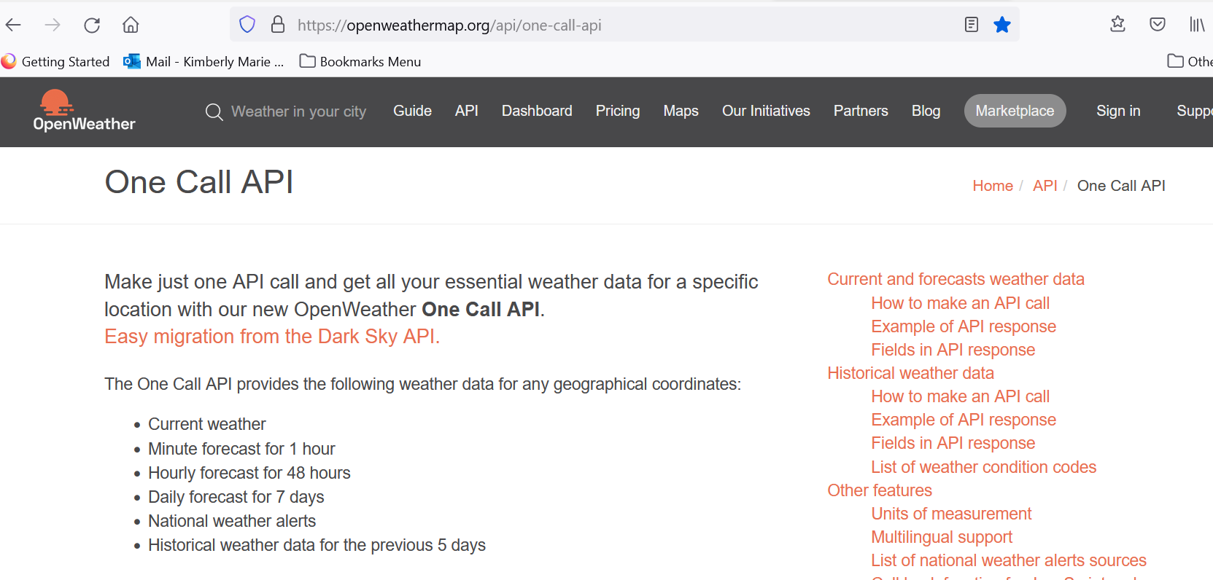

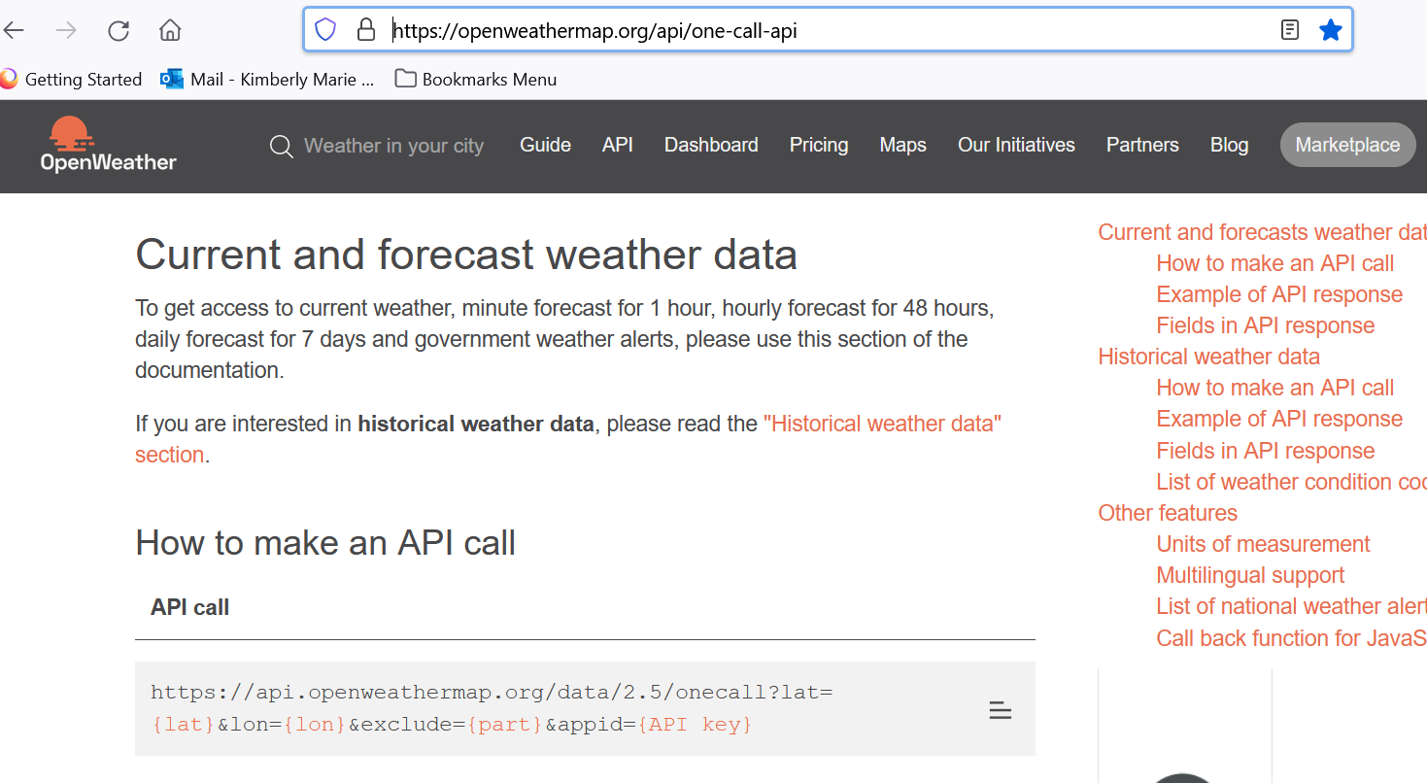

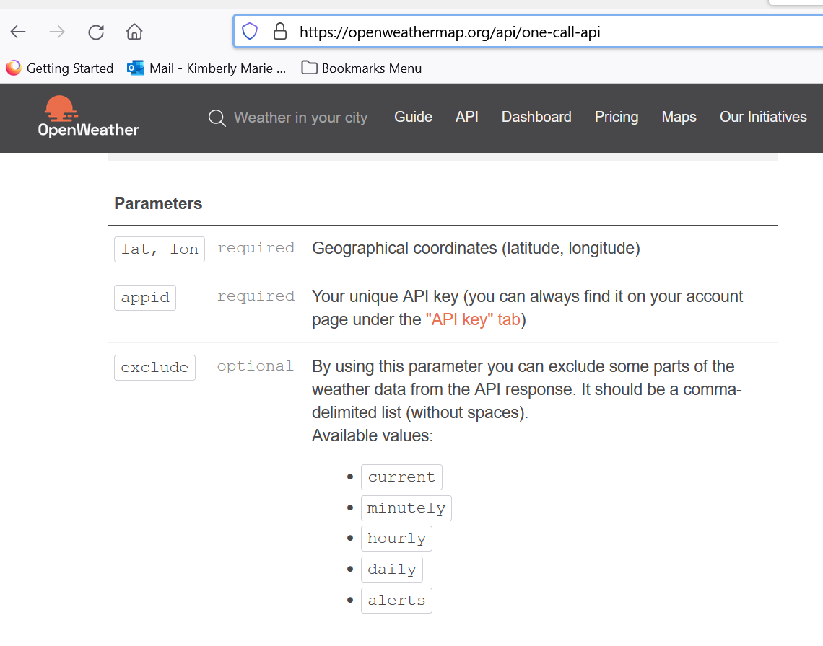

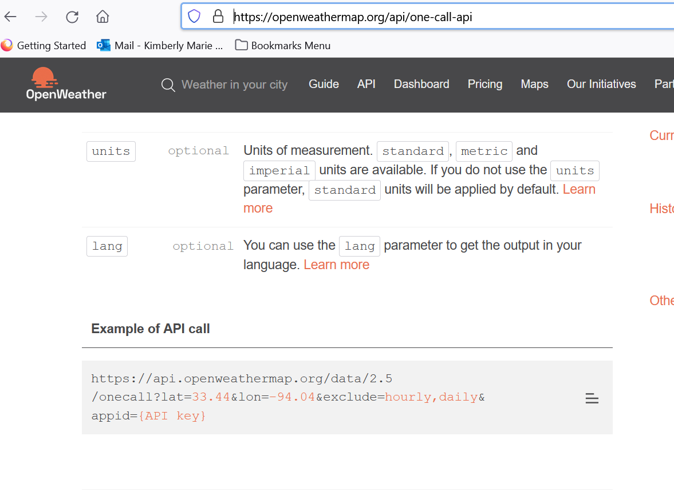

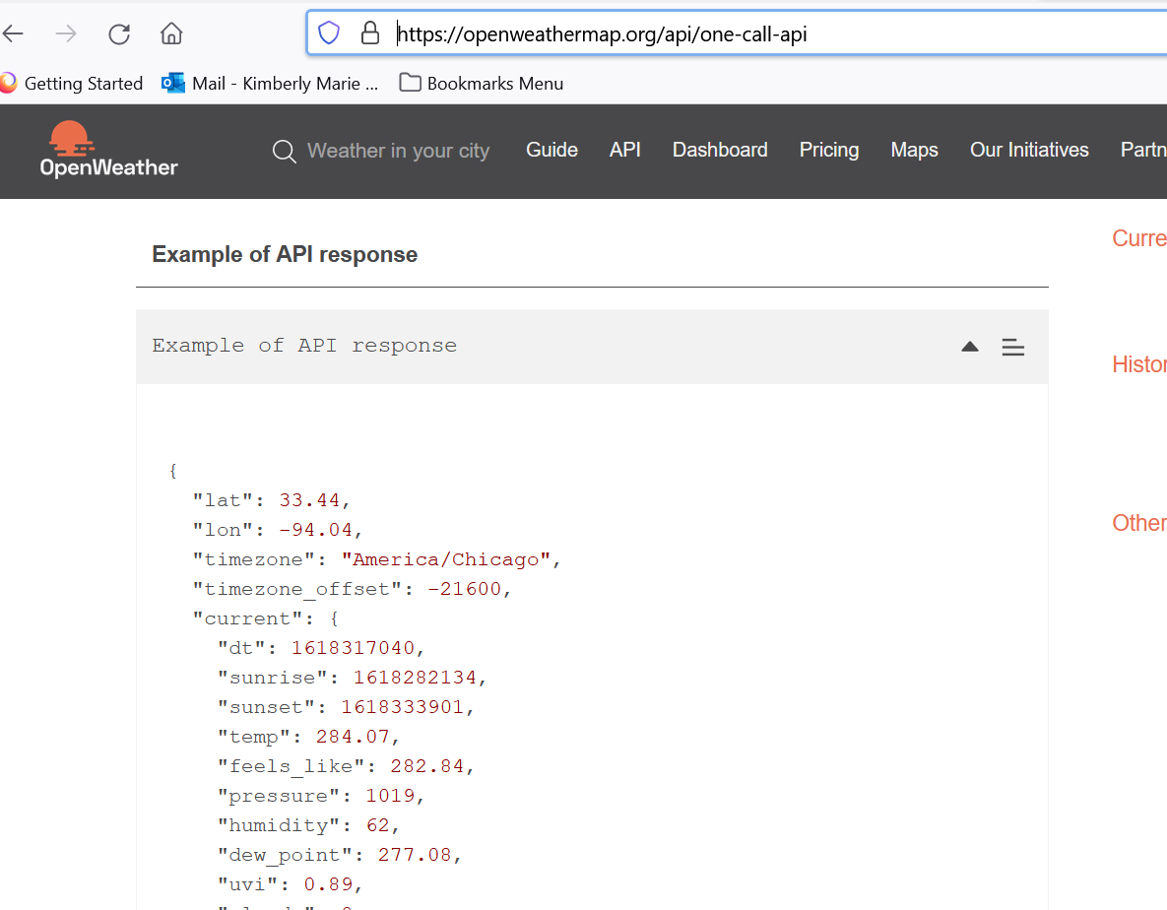

Fields in API response

* lat Geographical coordinates of the location (latitude)
* lon Geographical coordinates of the location (longitude)
* timezone Timezone name for the requested location
* timezone_offset Shift in seconds from UTC
* current **Current weather data API response**
  + current.dt Current time, Unix, UTC
  + current.sunrise Sunrise time, Unix, UTC
  + current.sunset Sunset time, Unix, UTC
  + current.temp Temperature. Units - default: kelvin, metric: Celsius, imperial: Fahrenheit. [How to change units used](https://openweathermap.org/api/one-call-api#data)
  + current.feels_like Temperature. This temperature parameter accounts for the human perception of weather. Units – default: kelvin, metric: Celsius, imperial: Fahrenheit.
  + current.pressure Atmospheric pressure on the sea level, hPa
  + current.humidity Humidity, %
  + current.dew_point Atmospheric temperature (varying according to pressure and humidity) below which water droplets begin to condense and dew can form. Units – default: kelvin, metric: Celsius, imperial: Fahrenheit.
  + current.clouds Cloudiness, %
  + current.uvi Current UV index
  + current.visibility Average visibility, metres
  + current.wind_speed Wind speed. Wind speed. Units – default: metre/sec, metric: metre/sec, imperial: miles/hour. [How to change units used](https://openweathermap.org/api/one-call-api#data)
  + current.wind_gust (where available) Wind gust. Units – default: metre/sec, metric: metre/sec, imperial: miles/hour. [How to change units used](https://openweathermap.org/api/one-call-api#data)
  + current.wind_deg Wind direction, degrees (meteorological)
  + current.rain
    - current.rain.1h (where available) Rain volume for last hour, mm
  + current.snow
    - current.snow.1h (where available) Snow volume for last hour, mm
  + current.weather
    - current.weather.id [Weather condition id](https://openweathermap.org/weather-conditions#Weather-Condition-Codes-2)
    - current.weather.main Group of weather parameters (Rain, Snow, Extreme etc.)
    - current.weather.description Weather condition within the group ([full list of weather conditions](https://openweathermap.org/weather-conditions#Weather-Condition-Codes-2)). Get the output in [your language](https://openweathermap.org/api/one-call-api#multi)
    - current.weather.icon Weather icon id. [How to get icons](https://openweathermap.org/weather-conditions#How-to-get-icon-URL)
* minutely **Minute forecast weather data API response**
  + minutely.dt Time of the forecasted data, unix, UTC
  + minutely.precipitation Precipitation volume, mm
* hourly **Hourly forecast weather data API response**
  + hourly.dt Time of the forecasted data, Unix, UTC
  + hourly.temp Temperature. Units – default: kelvin, metric: Celsius, imperial: Fahrenheit. [How to change units used](https://openweathermap.org/api/one-call-api#data)
  + hourly.feels_like Temperature. This accounts for the human perception of weather. Units – default: kelvin, metric: Celsius, imperial: Fahrenheit.
  + hourly.pressure Atmospheric pressure on the sea level, hPa
  + hourly.humidity Humidity, %
  + hourly.dew_point Atmospheric temperature (varying according to pressure and humidity) below which water droplets begin to condense and dew can form. Units – default: kelvin, metric: Celsius, imperial: Fahrenheit.
  + hourly.uvi UV index
  + hourly.clouds Cloudiness, %
  + hourly.visibility Average visibility, metres
  + hourly.wind_speed Wind speed. Units – default: metre/sec, metric: metre/sec, imperial: miles/hour.[How to change units used](https://openweathermap.org/api/one-call-api#data)
  + hourly.wind_gust (where available) Wind gust. Units – default: metre/sec, metric: metre/sec, imperial: miles/hour. [How to change units used](https://openweathermap.org/api/one-call-api#data)
  + chourly.wind_deg Wind direction, degrees (meteorological)
  + hourly.pop Probability of precipitation
  + hourly.rain
    - hourly.rain.1h (where available) Rain volume for last hour, mm
  + hourly.snow
    - hourly.snow.1h (where available) Snow volume for last hour, mm
  + hourly.weather
    - hourly.weather.id [Weather condition id](https://openweathermap.org/weather-conditions#Weather-Condition-Codes-2)
    - hourly.weather.main Group of weather parameters (Rain, Snow, Extreme etc.)
    - hourly.weather.description Weather condition within the group ([full list of weather conditions](https://openweathermap.org/weather-conditions#Weather-Condition-Codes-2)). Get the output in [your language](https://openweathermap.org/api/one-call-api#multi)
    - hourly.weather.icon Weather icon id. [How to get icons](https://openweathermap.org/weather-conditions#How-to-get-icon-URL)
* daily **Daily forecast weather data API response**
  + daily.dt Time of the forecasted data, Unix, UTC
  + daily.sunrise Sunrise time, Unix, UTC
  + daily.sunset Sunset time, Unix, UTC
  + daily.moonrise The time of when the moon rises for this day, Unix, UTC
  + daily.moonset The time of when the moon sets for this day, Unix, UTC
  + daily.moon_phase Moon phase. 0 and 1 are 'new moon', 0.25 is 'first quarter moon', 0.5 is 'full moon' and 0.75 is 'last quarter moon'. The periods in between are called 'waxing crescent', 'waxing gibous', 'waning gibous', and 'waning crescent', respectively.
  + daily.temp Units – default: kelvin, metric: Celsius, imperial: Fahrenheit. [How to change units used](https://openweathermap.org/api/one-call-api#data)
    - daily.temp.morn Morning temperature.
    - daily.temp.day Day temperature.
    - daily.temp.eve Evening temperature.
    - daily.temp.night Night temperature.
    - daily.temp.min Min daily temperature.
    - daily.temp.max Max daily temperature.
  + daily.feels_like This accounts for the human perception of weather. Units – default: kelvin, metric: Celsius, imperial: Fahrenheit. [How to change units used](https://openweathermap.org/api/one-call-api#data)
    - daily.feels_like.morn Morning temperature.
    - daily.feels_like.day Day temperature.
    - daily.feels_like.eve Evening temperature.
    - daily.feels_like.night Night temperature.
  + daily.pressure Atmospheric pressure on the sea level, hPa
  + daily.humidity Humidity, %
  + daily.dew_point Atmospheric temperature (varying according to pressure and humidity) below which water droplets begin to condense and dew can form. Units – default: kelvin, metric: Celsius, imperial: Fahrenheit.
  + daily.wind_speed Wind speed. Units – default: metre/sec, metric: metre/sec, imperial: miles/hour. [How to change units used](https://openweathermap.org/api/one-call-api#data)
  + daily.wind_gust (where available) Wind gust. Units – default: metre/sec, metric: metre/sec, imperial: miles/hour. [How to change units used](https://openweathermap.org/api/one-call-api#data)
  + daily.wind_deg Wind direction, degrees (meteorological)
  + daily.clouds Cloudiness, %
  + daily.uvi The maximum value of UV index for the day
  + daily.pop Probability of precipitation
  + daily.rain (where available) Precipitation volume, mm
  + daily.snow (where available) Snow volume, mm
  + daily.weather
    - daily.weather.id [Weather condition id](https://openweathermap.org/weather-conditions#Weather-Condition-Codes-2)
    - daily.weather.main Group of weather parameters (Rain, Snow, Extreme etc.)
    - daily.weather.description Weather condition within the group ([full list of weather conditions](https://openweathermap.org/weather-conditions#Weather-Condition-Codes-2)). Get the output in [your language](https://openweathermap.org/api/one-call-api#multi)
    - daily.weather.icon Weather icon id. [How to get icons](https://openweathermap.org/weather-conditions#How-to-get-icon-URL)
* alerts **National weather alerts data from major national weather warning systems**
  + alerts.sender_name Name of the alert source. Please read here the [full list of alert sources](https://openweathermap.org/api/one-call-api#listsource)
  + alerts.event Alert event name
  + alerts.start Date and time of the start of the alert, Unix, UTC
  + alerts.end Date and time of the end of the alert, Unix, UTC
  + alerts.description Description of the alert
  + alerts.tags Type of severe weather

National weather alerts are provided in English by default.  
 Please note that some agencies provide the alert’s description only in a local language.

### List of weather condition codes

List of [weather condition codes](https://openweathermap.org/weather-conditions) with icons (range of thunderstorm, drizzle, rain, snow, clouds, atmosphere including extreme conditions like tornado, hurricane etc.)

## Other features

### Units of measurement

standard, metric and imperial units are available.

[List of all API parameters with available units.](http://openweathermap.org/weather-data)

API call

<http://api.openweathermap.org/data/2.5/onecall?lat={lat}&lon={lon}&units={units>}

|  |  |  |
| --- | --- | --- |
| **Parameters** | | |
| units | optional | Units of measurement. standard, metric and imperial units are available. If you do not use the units parameter, standard units will be applied by default. |

Temperature is available in Fahrenheit, Celsius and Kelvin units.

Wind speed is available in miles/hour and meter/sec.

* For temperature in Fahrenheit and wind speed in miles/hour, use units=imperial
* For temperature in Celsius and wind speed in meter/sec, use units=metric
* Temperature in Kelvin and wind speed in meter/sec is used by default, so there is no need to use the units parameter in the API call if you want this

Examples of API calls

Standard (default)

api.openweathermap.org/data/2.5/onecall?lat=30.489772&lon=-99.771335

Metric

api.openweathermap.org/data/2.5/onecall?lat=30.489772&lon=-99.771335&units=metric

Imperial

api.openweathermap.org/data/2.5/onecall?lat=30.489772&lon=-99.771335&units=imperial

<https://openweathermap.org/price>

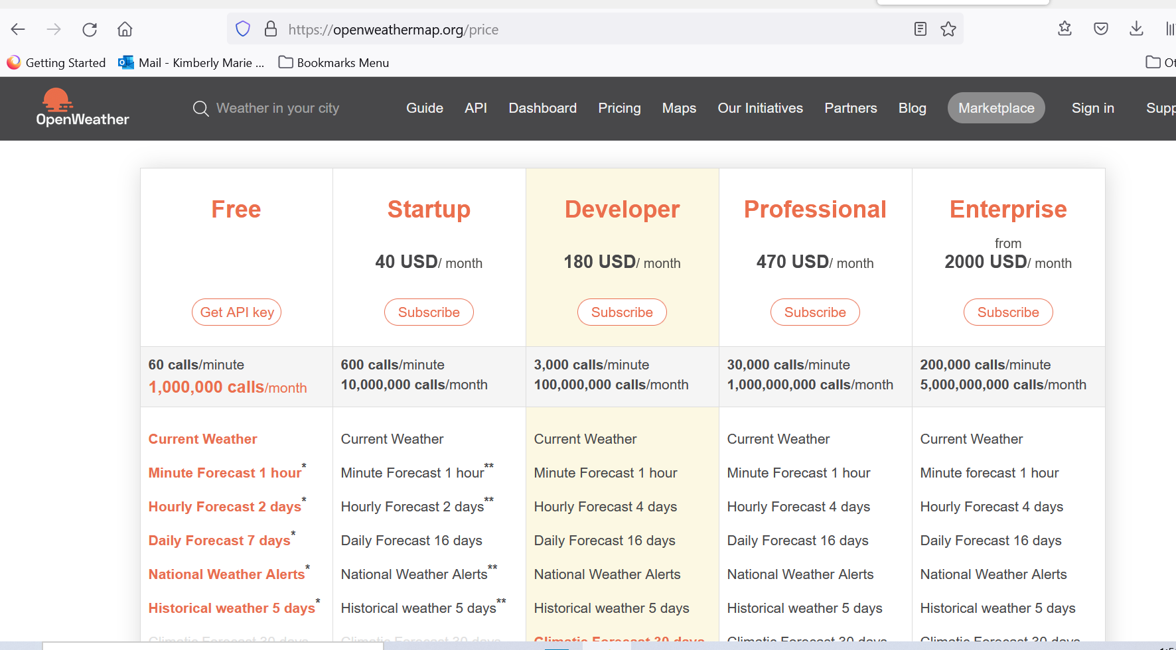

Click on API in black banner

<https://openweathermap.org/api>

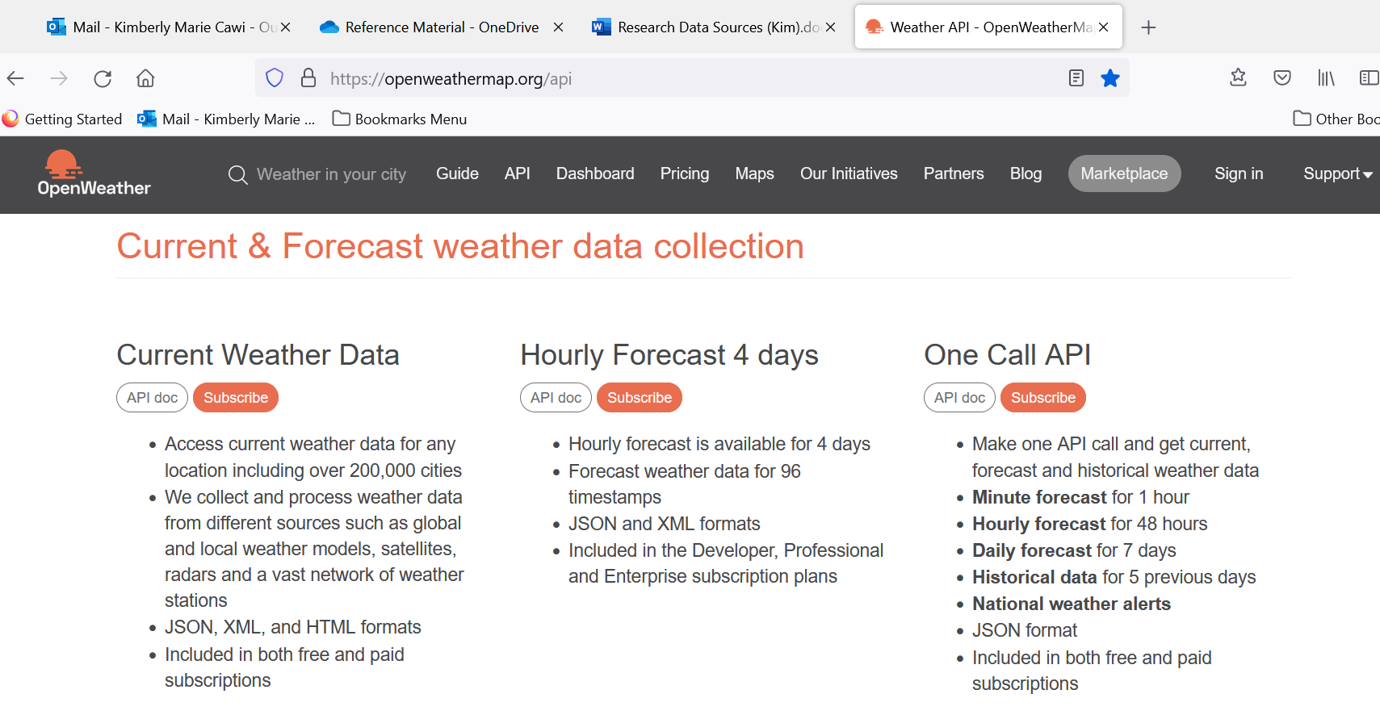

Click Subscribe under the One Call API: takes you here <https://openweathermap.org/full-price#current>

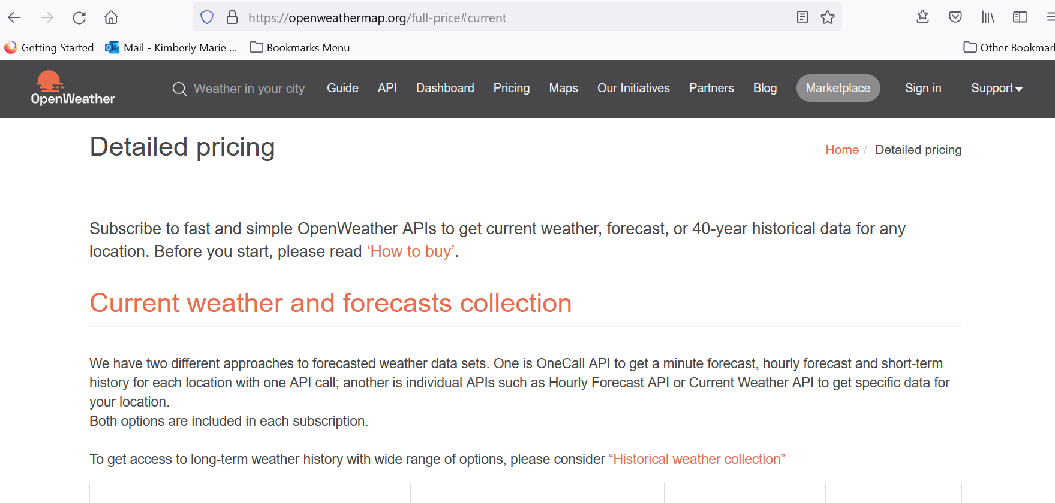

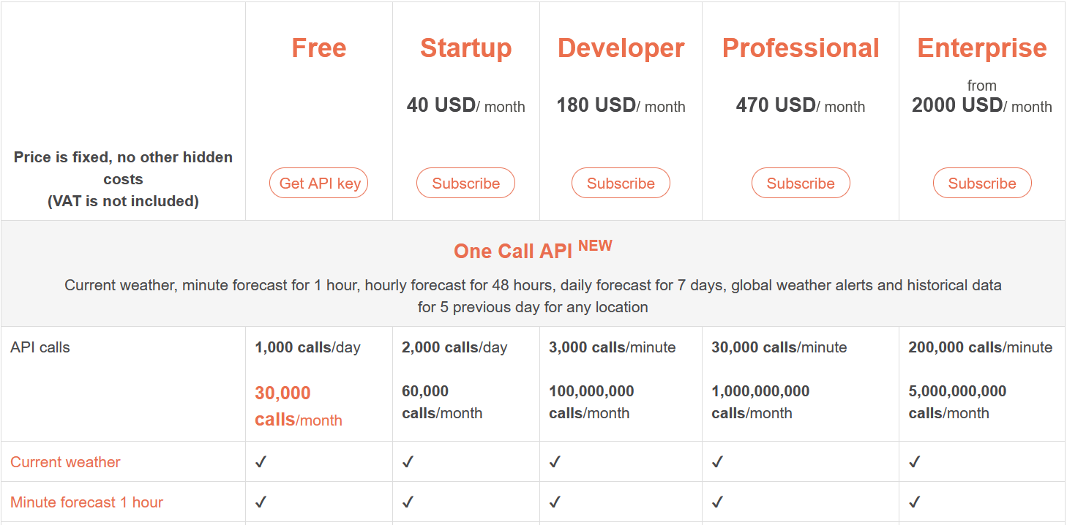

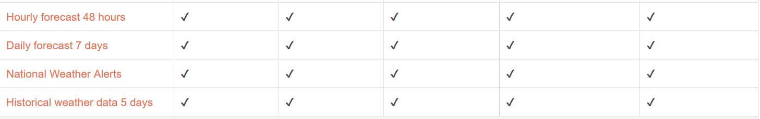

Click Get API Key from Free Column 1,000 calls per day and 30,000 calls per month

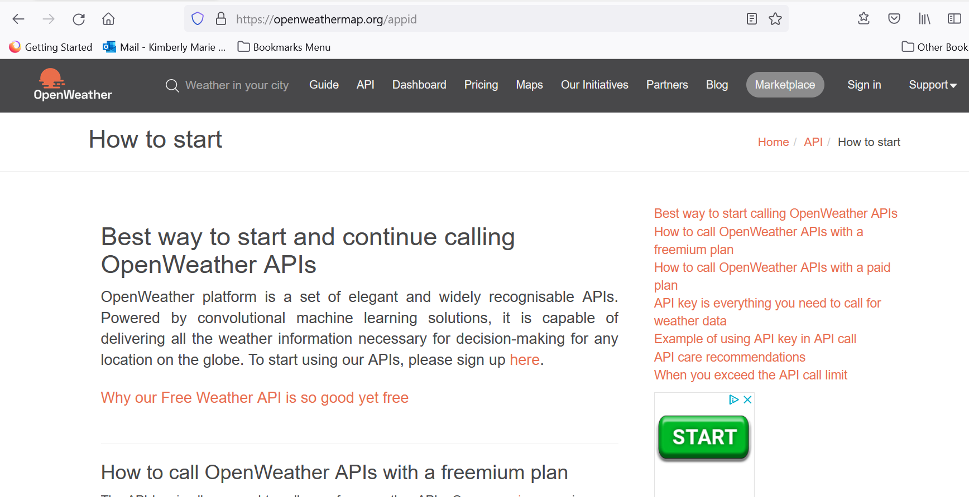

Click sign up here. Fill out form.

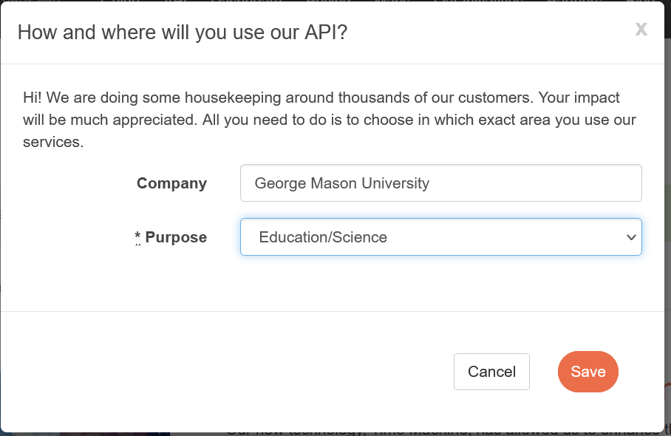

Click Save

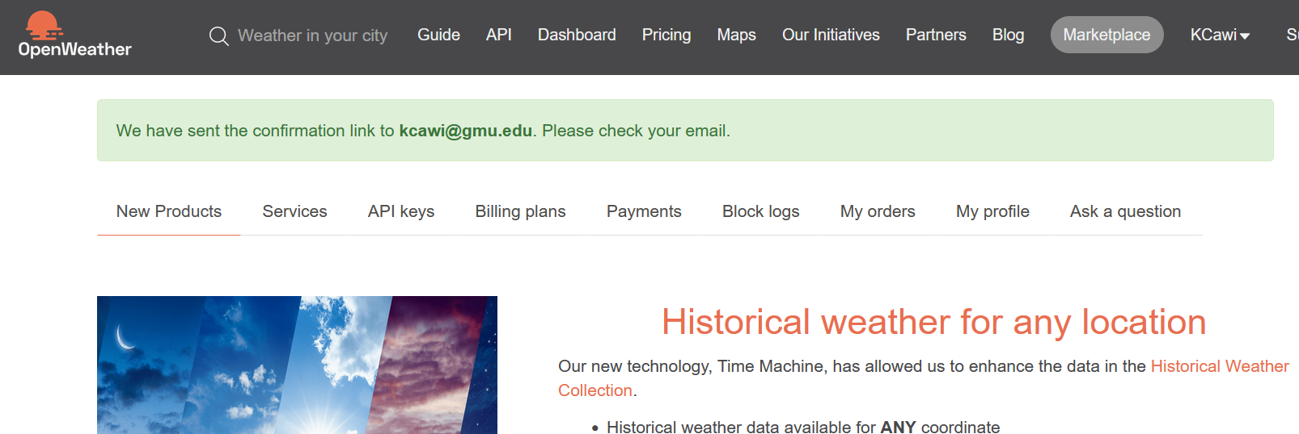

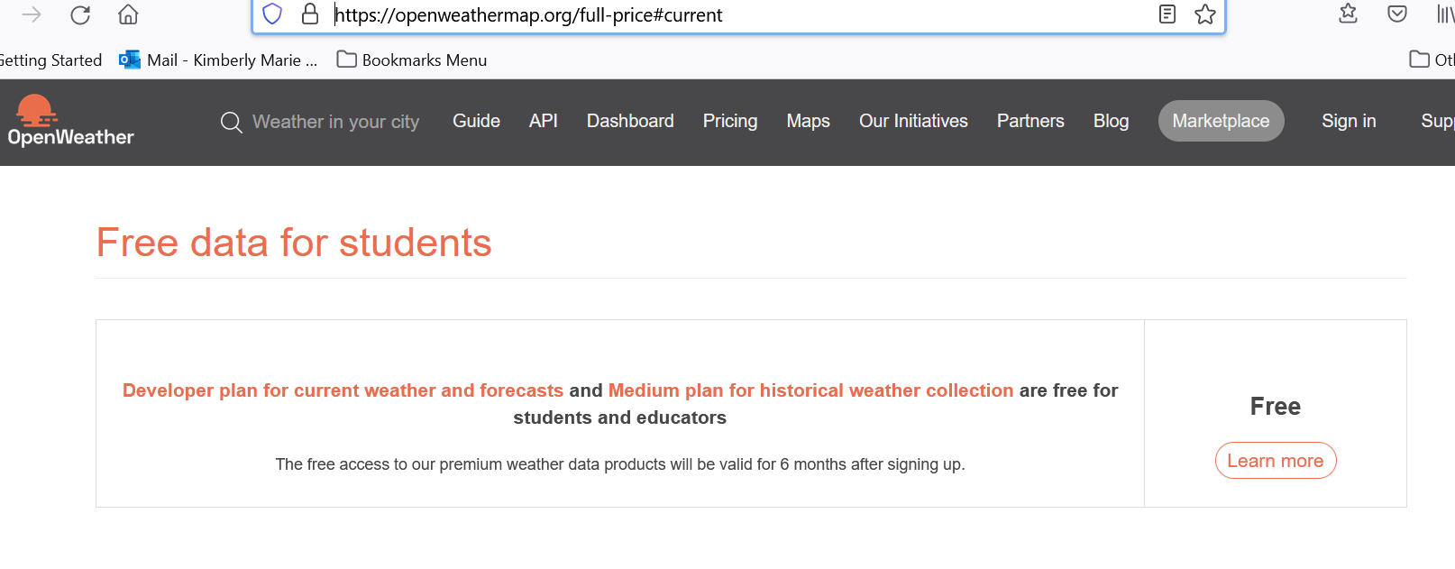

Click on Learn more

Note: For Students- can get the Developer plan for forecasts for 6 months.

<https://openweathermap.org/our-initiatives/student-initiative>

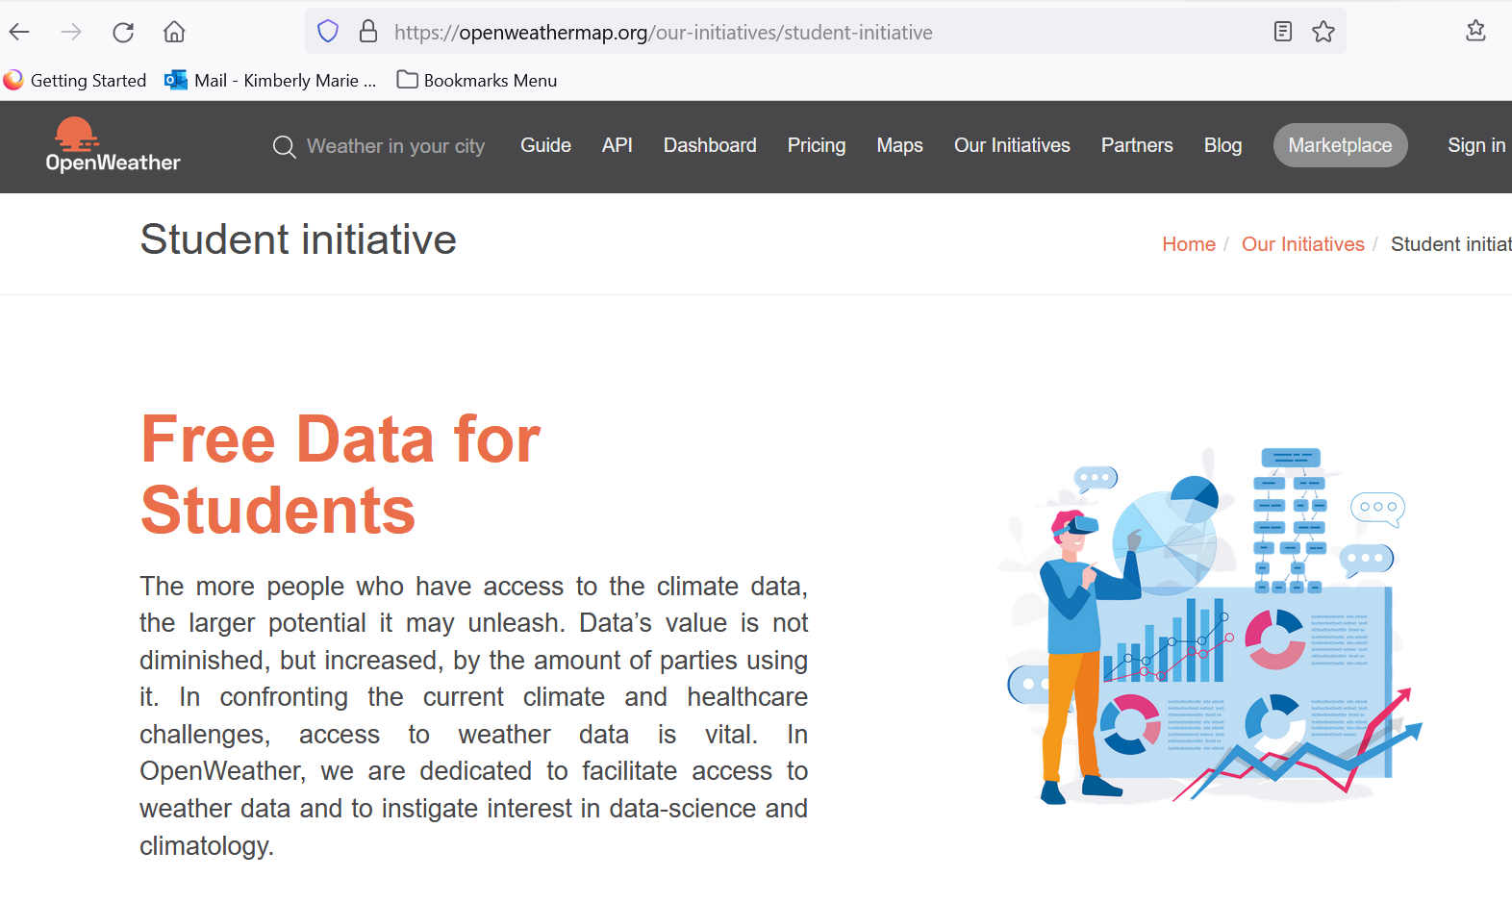

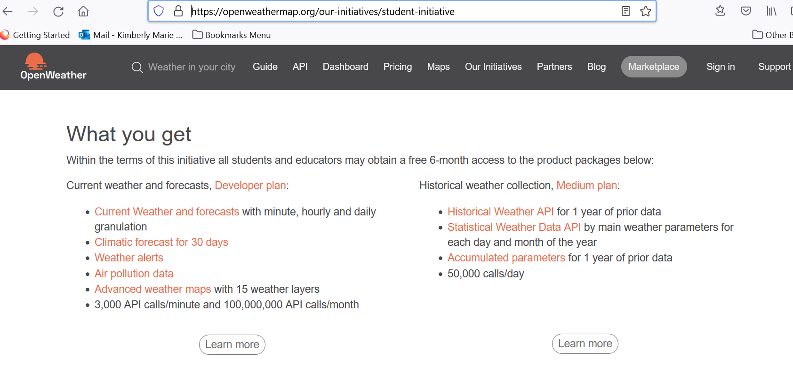

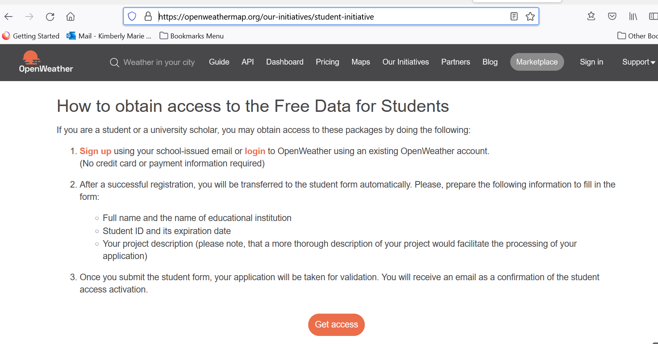

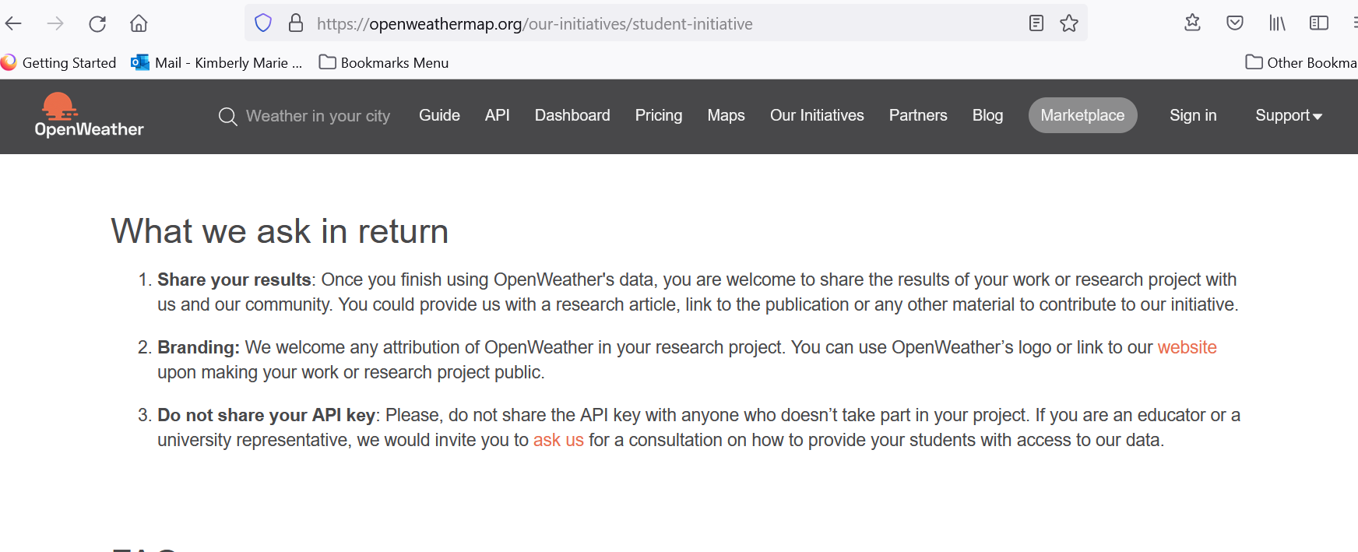

<https://openweathermap.org/technology>

## Why our Free Weather API is so good yet free

Such powerful technologies as our ML can significantly advance both the accuracy and computing speed of global assemble forecasting models, a practice that was impossible only a few years ago. That makes the entire calculation fast and cost-effective, providing millions of customers with accurate forecasts promptly.

### Weather data should be open to anyone

Not many types of data can affect business decisions and personal everyday plans on the same scale as weather data does. And that is not to mention the billions of dollars that businesses and governments are losing indeed due to extreme weather conditions that are beyond their control. However, most applications of accurate forecasts and history for businesses are more routine, yet more practical for daily analysis and decision-making. To name just a few, these include analysis of the impact of weather on customers’ demand for retailers, planning of safe routes for transport companies, accurate evaluation of customers’ cases for insurers, sensitive planning of energy consumption for householders, and timely watering of crops for farmers.

### Modern technologies make accurate weather data not only widely available, but also nearly free

What seemed impossible just a few years ago, you can now do at lightning speed. Machine learning (ML), neural networks, big data, cloud spaces – all of this is easily accessible for calculating hugely sophisticated forecasting models such as Numerical Weather Prediction (NWP) or short-term forecasts that update rapidly.

### ML empowers the classic forecasting models

When it comes to the computing and valuation of complex hydro-meteorological models, we rely on the most honourable agencies such as NOAA, Met Office, ECMWF, Environmental Canada. But we can enhance their models with our knowledge of data science and ML, given that most of the mathematics behind forecasting is well-known. For example, the forecasting algorithms for its extreme form, nowcast, have been in use since the 1950s’ radar data is open, and even free for some territories. Additionally, there are lots of specialised instruments for developers, such as Python libraries for the STEP (Short-term Ensemble Prediction System) computation.

### Plethora of open weather data to be fed the ML model

Fortunately, global meteorological companies such as NOAA, the Met Office, Environment Canada and ECMWF share our belief that weather data should be open. They supply us with enormous data feeds, including data from radars, weather satellites and weather stations. They also provide a lot of more specialised products such as road alerts, road risks and marine weather.

**List of Open Weather weather condition names in response under main and description**

<https://openweathermap.org/weather-conditions#Weather-Condition-Codes-2>

**Unix UTC internet explanation – used in daily:dt field for Open Weather**

<https://kb.narrative.io/what-is-unix-time>

## **Convert epoch to human-readable date and vice versa**

<https://www.epochconverter.com/>

## **Convert Unix time to datetime: fromtimestamp()**

<https://note.nkmk.me/en/python-unix-time-datetime/>

**Open Weather Response in JSON**

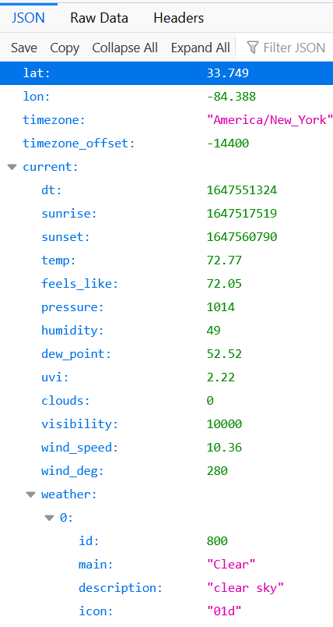

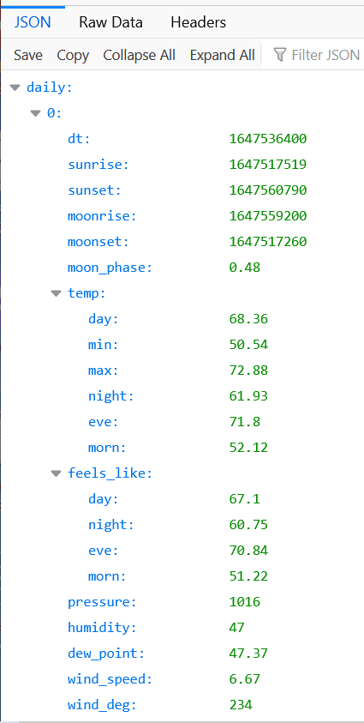

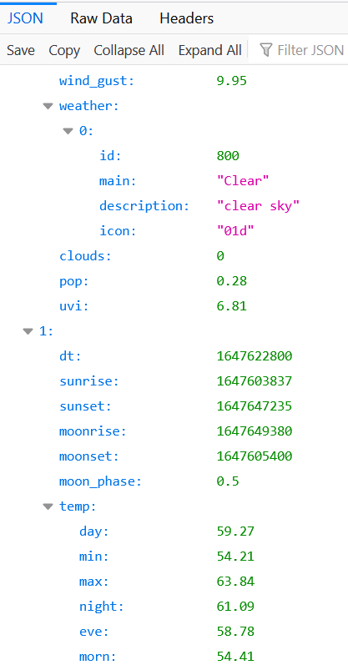

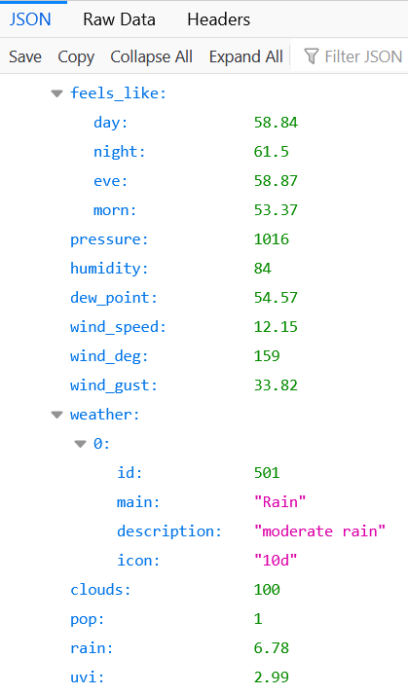

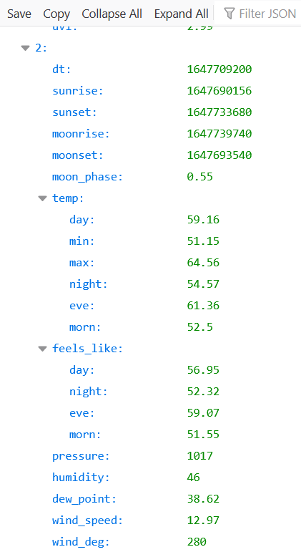

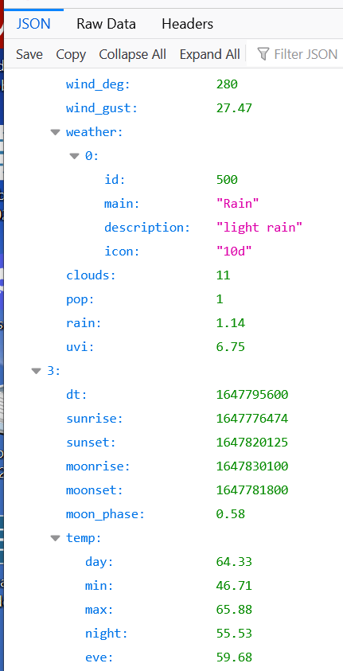

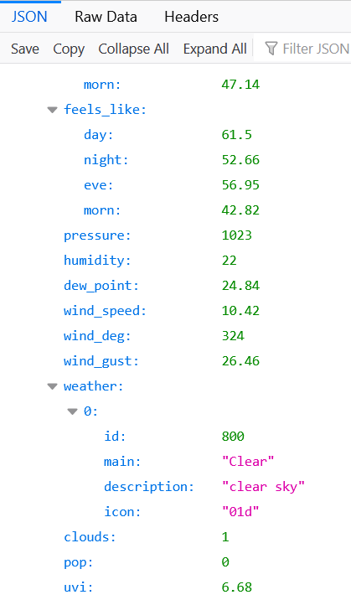

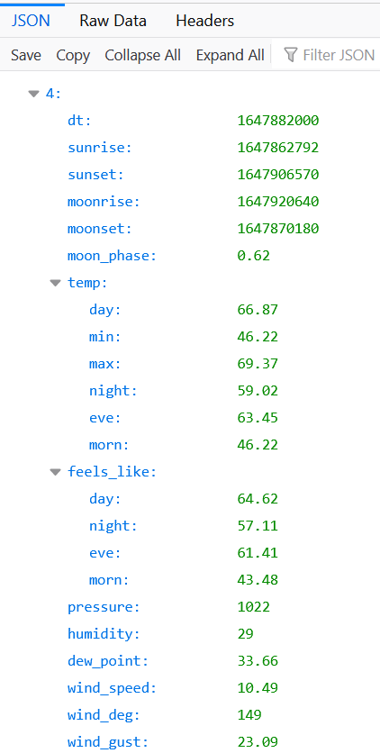

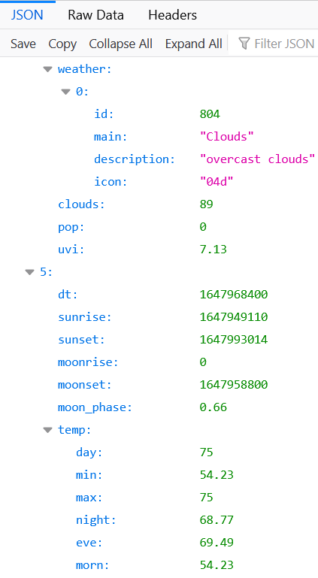

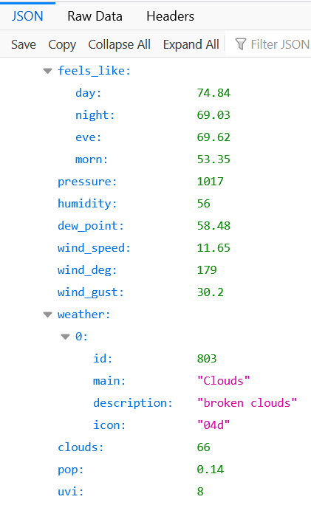

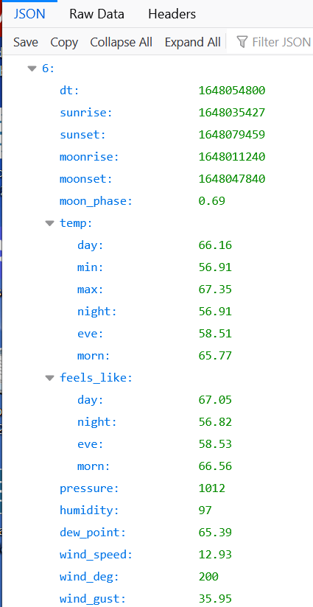

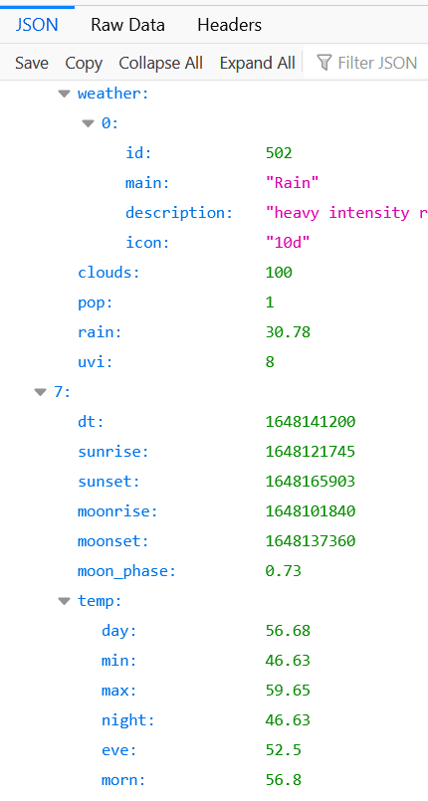

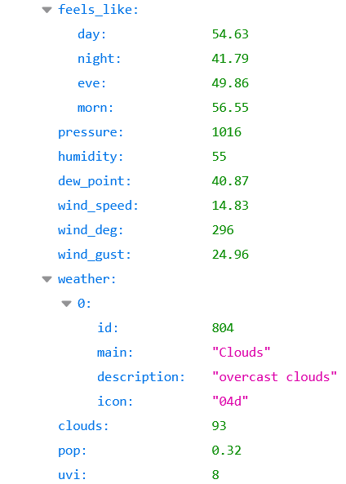

**Open Weather Historical Weather Information for History Forecast Bulk API**

Note: Price $45/location

<https://openweathermap.org/api>

### Click Doc under History Forecast Bulk

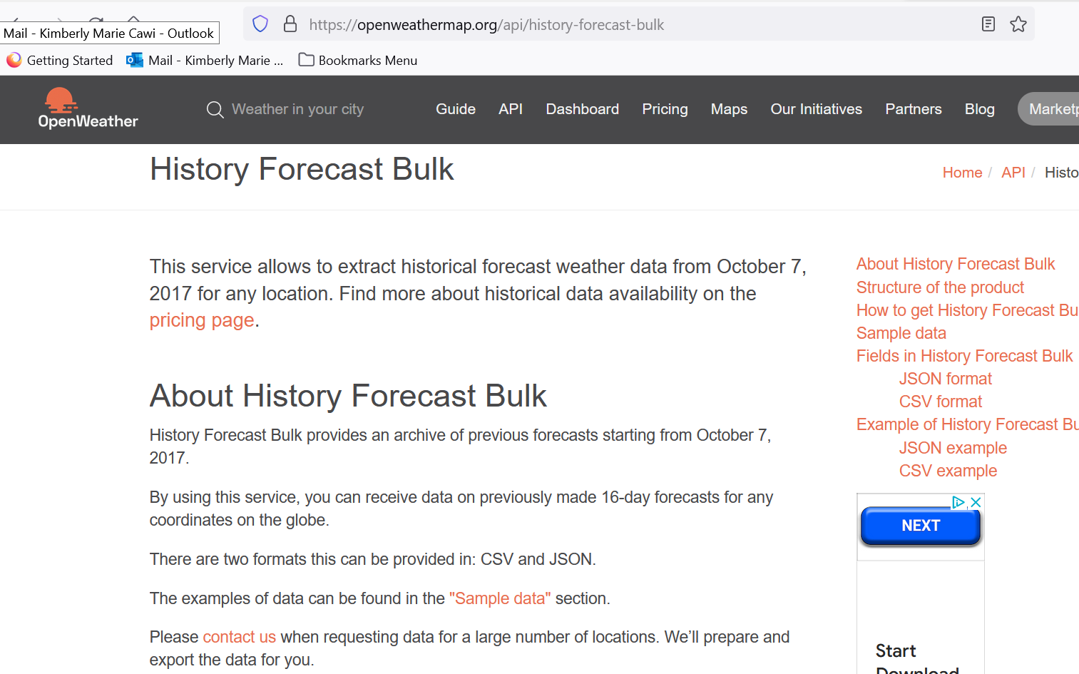

### JSON format

* Time of the forecast recalculation cycle, unix, UTC
* main
  + main.pressure Atmospheric pressure (on the sea level), hPa
  + main.grnd_pressure Atmospheric pressure (on the surface), hPa
  + main.temp Temperature
  + main.dew_point Temperature of the dew point
  + main.humidity Humidity, %
* precipitation
  + precipitation.snow_depth Depth of snow, cm
  + precipitation.snow Snow water equivalent, mm
  + precipitation.rain Rain, mm
  + precipitation.hours Number of hours for which precipitation values are calculated
  + precipitation.rate Intensity, mm/s
  + precipitation.fr_rain Freezing rain, mm
  + precipitation.ice Ice pellets, mm
* wind
  + wind.speed Wind speed
  + wind.deg Wind direction, degrees (meteorological)
* clouds
  + clouds.all Cloudiness, %
* dt Date for which the forecast is made, unix, UTC

### CSV format

* forecast dt unixtime Forecast calculation time in unix timestamp
* forecast dt iso Forecast calculation time in ISO format
* slice dt unixtime Time for which the corresponding forecast part was calculated in unix timestamp
* slice dt iso Time for which the corresponding forecast part was calculated in ISO format
* lat Latitude
* lon Longitude
* temperature Temperature
* dew_point Temperature of the dew point

* pressure Atmospheric pressure (on the sea level), hPa

* ground_pressure Atmospheric pressure (on the surface), hPa

* humidity Humidity, %
* clouds
* wind_speed Wind speed
* wind_deg Wind direction, degrees (meteorological)

* rain Rain, mm

* snow Snow water equivalent, mm
* ice Ice pellets, mm

* fr_rain Freezing rain volume, mm
* convective Convective precipitation, mm
* snow_depth Depth of snow, cm
* accumulated Accumulated volume of precipitation, mm
* hours Number of hours for which precipitation values are calculated
* rate Precipitation intensity, mm/s
* probability Probability of precipitation

Click “Buy History Forecast Bulk”

For Pricing on History Forecast Bulk:

<https://openweathermap.org/api>

### Click Subscribe under One Call API

<https://openweathermap.org/full-price#current>

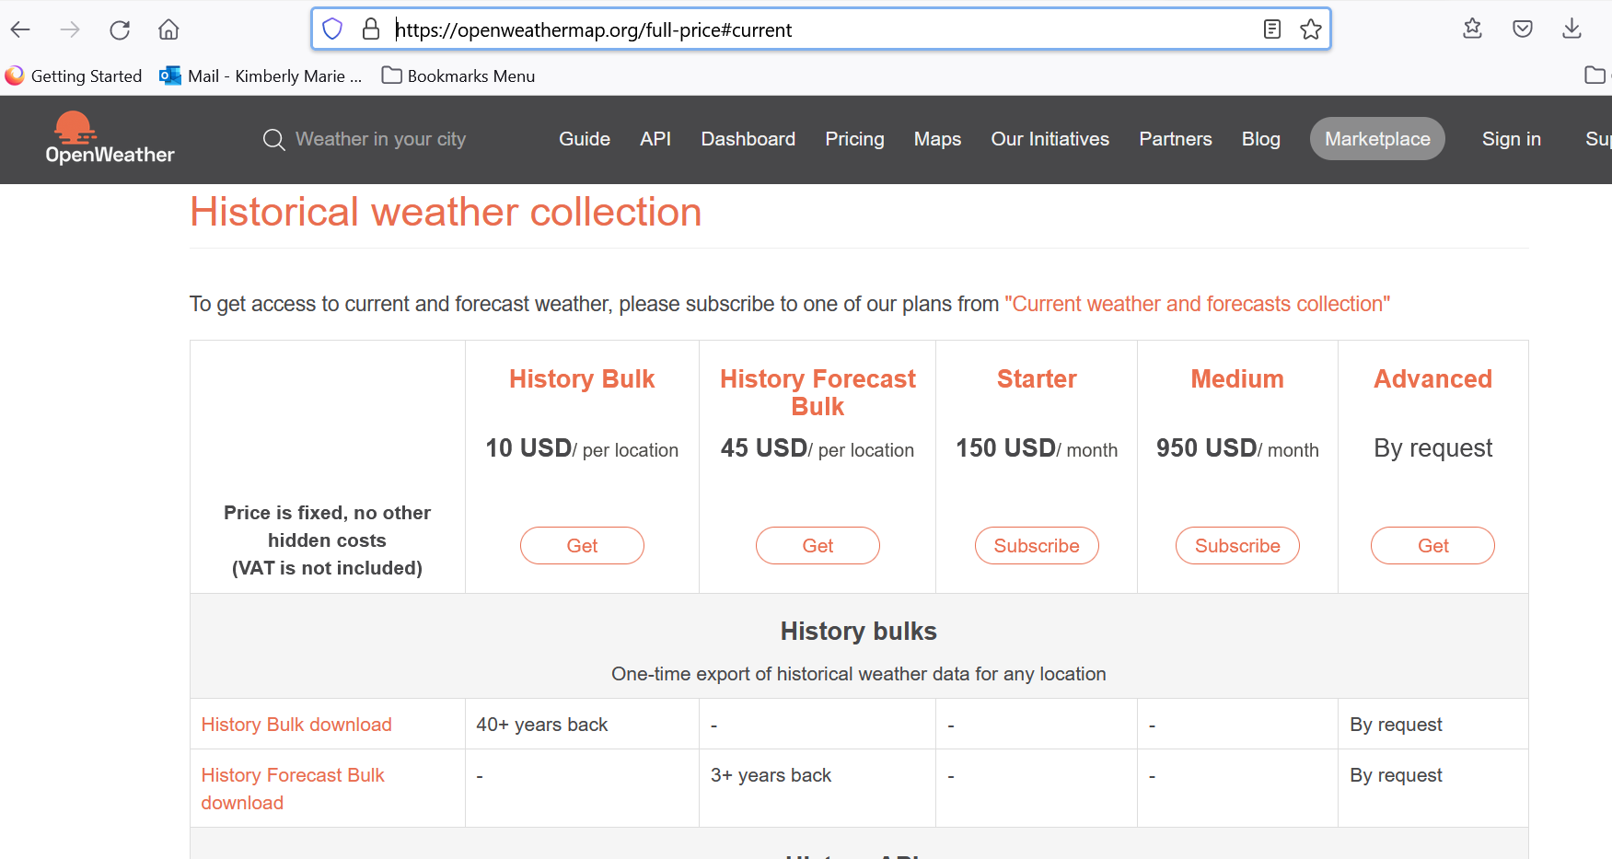

Click “get” under History Forecast Bulk

<https://home.openweathermap.org/marketplace>

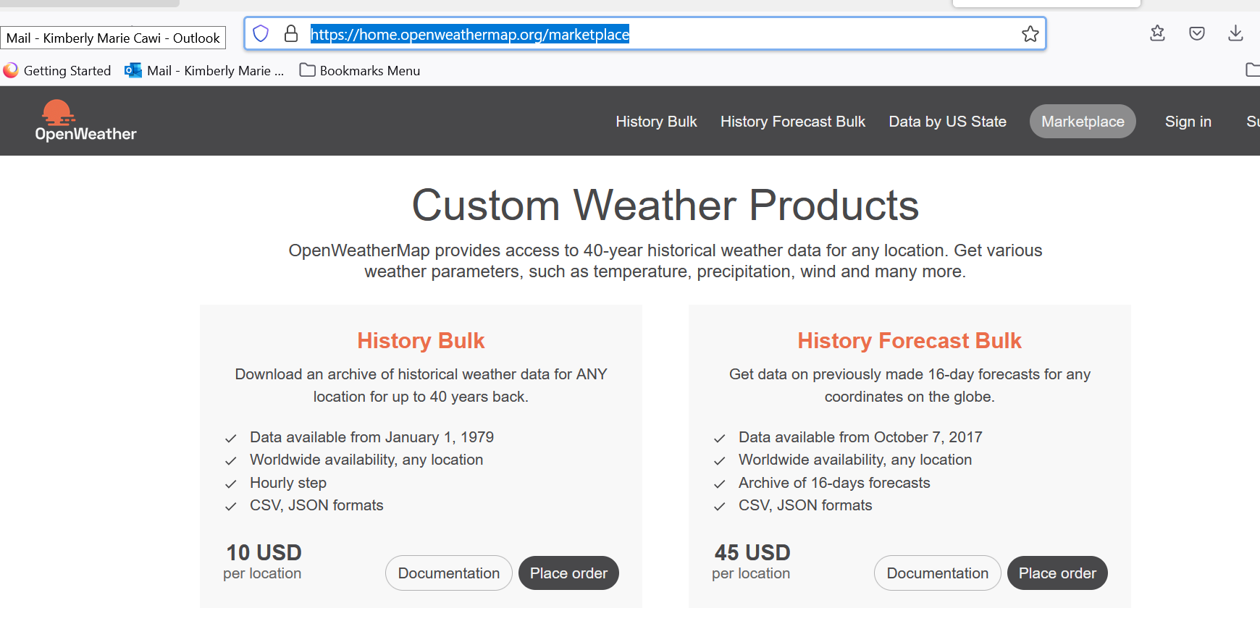

**Open Weather Historical Weather Information for History Bulk API**

Note: Price $10/location

<https://openweathermap.org/api>

Click Doc under History Bulk

<https://openweathermap.org/history-bulk>

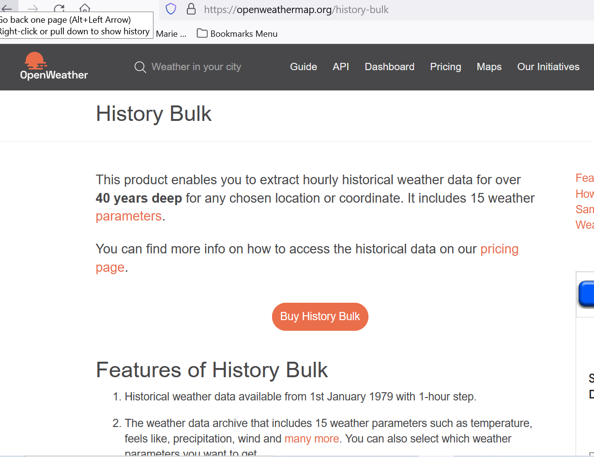

## Sample data

There are two formats of files History Bulk can be provided in. Please find the examples below:

JSON  
 [CSV](http://samples.openweathermap.org/storage/history_bulk.csv?appid=b1b15e88fa797225412429c1c50c122a1)

## Weather fields in History Bulk

If you do not see some of the parameters in your bulk, it means that these weather phenomena just have not happened in the chosen time period at the chosen location. Only really measured or calculated data is displayed in your bulk.

### Parameters

* city_name City name
* lat Geographical coordinates of the location (latitude)
* lon Geographical coordinates of the location (longitude)
* main
  + main.temp Temperature
  + main.temp_min Minimum temperature at the moment. This is deviation from temperature that is possible for large cities and megalopolises geographically expanded (use these parameter optionally).
  + main.temp_max Maximum temperature at the moment. This is deviation from temperature that is possible for large cities and megalopolises geographically expanded (use these parameter optionally).
  + main.feels_like This temperature parameter accounts for the human perception of weather
  + main.pressure Atmospheric pressure (on the sea level), hPa
  + main.humidity Humidity, %
  + main.dew_point Atmospheric temperature (varying according to pressure and humidity) below which water droplets begin to condense and dew can form. Units – default: kelvin
* wind
  + wind.speed Wind speed. Units – default: meter/sec
  + wind.deg Wind direction, degrees (meteorological)
  + wind.gust Wind gust. Units – default: meter/sec
* clouds
  + clouds.all Cloudiness, %
* rain
  + rain.1h Rain volume for the last hour, mm
  + rain.3h Rain volume for the last 3 hours, mm
* snow
  + snow.1h Snow volume for the last hour, mm (in liquid state)
  + snow.3h Snow volume for the last 3 hours, mm (in liquid state)
* weather (more info [Weather condition codes](https://openweathermap.org/weather-conditions))
  + weather.id Weather condition id
  + weather.main Group of weather parameters (Rain, Snow, Extreme etc.)
  + weather.description Weather condition within the group
  + weather.icon Weather [icon id](https://openweathermap.org/history-bulk#list)
* visibility Average visibility, metres. The maximum value of the visibility is 10km
* dt Time of data calculation, unix, UTC
* dt_isoDate and time in UTC format
* timezone Shift in seconds from UTC

### Example

JSON Example

[{  
 "city_name":"Custom location",  
 "lat":51.485927,  
 "lon":0.24995,  
 "main":{  
 "temp":277.72,  
 "temp_min":275.632,  
 "temp_max":279.15,  
 "feels_like":273.99,  
 "pressure":1029,  
 "humidity":75,  
 "dew_point" : 280.33  
 },  
 "wind":{  
 "speed":2.6,  
 "deg":10,  
 "gust": 5.8  
 },  
 "rain":{  
 "3h":1  
 },  
 "clouds":{  
 "all":75  
 },  
 "weather":[{  
 "id":500,  
 "main":"Rain",  
 "description":"light rain",  
 "icon":"10n"  
 }],  
 "visibility":10000,  
 "dt":1585612800,  
 "dt_iso":"2020-03-31 00:00:00 +0000 UTC",  
 "timezone":3600  
},

### List of weather condition codes

List of [weather condition codes](https://openweathermap.org/weather-conditions) with icons (range of thunderstorm, drizzle, rain, snow, clouds, atmosphere including extreme conditions like tornado, hurricane etc.)

---------------------------------------------------------------------------------------------------------------------------------

**AcuWeather**

<https://www.accuweather.com/en/us/leesburg/20176/february-weather/336204>

Note: Free trial then paid, did not use

-----------------------------------------------------------------------------------------------------------------------------------

# *****

# How to Get Weather Forecast Data in Jupyter Notebook

# Preamble

[National Oceanic and Atmospheric Administration](https://www.noaa.gov/) (aka NOAA) publishes 7 day weather forecasting data. In this publication, I am going to show how to get 7 day weather forecast data in a Python Jupyter Notebook from NOAA’s application interface.

<https://python.plainenglish.io/how-to-get-weather-forecast-data-in-your-jupyter-notebook-d93a092d63ec>

Code on google colaborate:

<https://colab.research.google.com/gist/sidbannet/2af23520b54847f150d64b2274633246/noaa-weather-forecast-data.ipynb#scrollTo=t17ETMGuvDSe>

Note: This works for temperature and wind speed. No Precipitation. Has Sunny, Cloudy, etc. Has forecast about a week. In python, it pulls forecast and puts into a pandas data frame. It uses api.weather.gov from NOAA. The reliability of the api is spotty. However, it is a good tutorial on how to decifer extract json into pandas dataframe.

Documentation for the api (documentation link found on <https://github.com/paulokuong/noaa> he used same api)

<https://www.weather.gov/documentation/services-web-api>

-------------------------------------------------------------------------------------------------------------------------------------------

**Climate expert**

**From:** Bernard Schmidt <bschmid5@gmu.edu>  
**Sent:** Thursday, February 17, 2022 7:28 PM  
**To:** Charles Howard <choward@gmu.edu>  
**Subject:** Re: Professor Link for Climate

Wenying Ji. Really great guy and very unassuming. Really easy to talk to.

[Wenying Ji | Sid and Reva Dewberry Department of Civil, Environmental, and Infrastructure Engineering (gmu.edu)](https://civil.gmu.edu/profiles/wji2)

**-------------------------------------------------------------------------------------------------------**

**SDK for NOAA Weather Service REST API for getting recent and forecast data.**

**Noaa-sdk python package**

<https://github.com/paulokuong/noaa>

<https://pypi.org/project/noaa-sdk/>

Note: Returns a very large, complicated dictionary

Documentation

<https://www.weather.gov/documentation/services-web-api>

# Api.weather.gov

## Community discussion and documentation for the US National Weather Service API

Welcome! This GitHub Pages site is here to answer some of the most frequently asked questions about the National Weather Service public data API (api.weather.gov).

GitHub for

<https://weather-gov.github.io/api/>

------------------------------------------------------------------------------------------------------------------------------

**From github Marty-Sullivan**

PyNDFD is an open source Python module that, in one line of code, retrieves up-to-date forecast data from the US National Weather Service (NWS) - National Digital Forecasting Database (NDFD). Data can be retrieved for any coordinate within the United States in a fraction of a second. Important decisions can be made easier with rain, wind, temperature and a multitude of other forecast variable monitoring. Weather advisories and weather descriptions are also constructed by PyNDFD

<https://github.com/marty-sullivan/pyndfd>

Note: Looks promising but I had trouble building pygrib

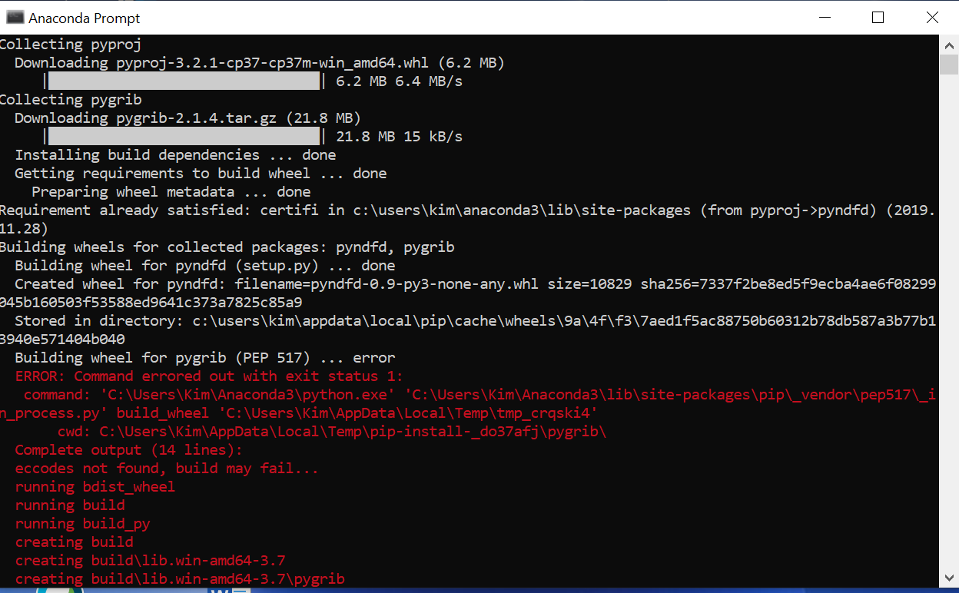

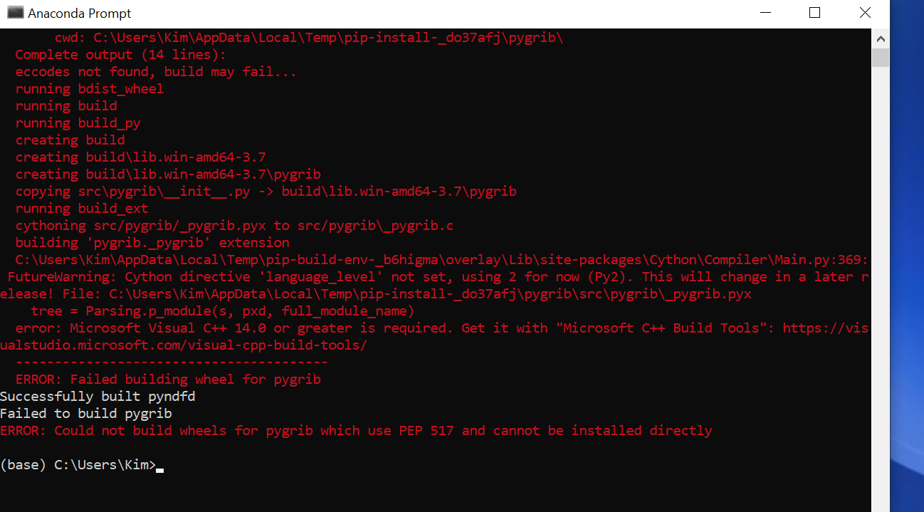

### --------------------------------------------------------------------------------------------------------------------

<https://pvlib-python.readthedocs.io/en/stable/forecasts.html#accessing-forecast-data>

pvlib python provides a set of functions and classes that make it easy to obtain weather forecast data and convert that data into a PV power forecast. Users can retrieve standardized weather forecast data relevant to PV power modeling from NOAA/NCEP/NWS models including the GFS, NAM, RAP, HRRR, and the NDFD.

<https://pvlib-python.readthedocs.io/en/stable/>

---------------------------------------------------------------------------------------------------------------------------------

**Tomorrow Python Weather API**

Note: Promising but charges for level we need. If doing 500 airports, we will need to be able to do more than 25 calls per hour.

<https://www.tomorrow.io/blog/creating-daily-forecasts-with-a-python-weather-api/>

<https://docs.tomorrow.io/reference/get-timelines>

<https://docs.tomorrow.io/recipes>

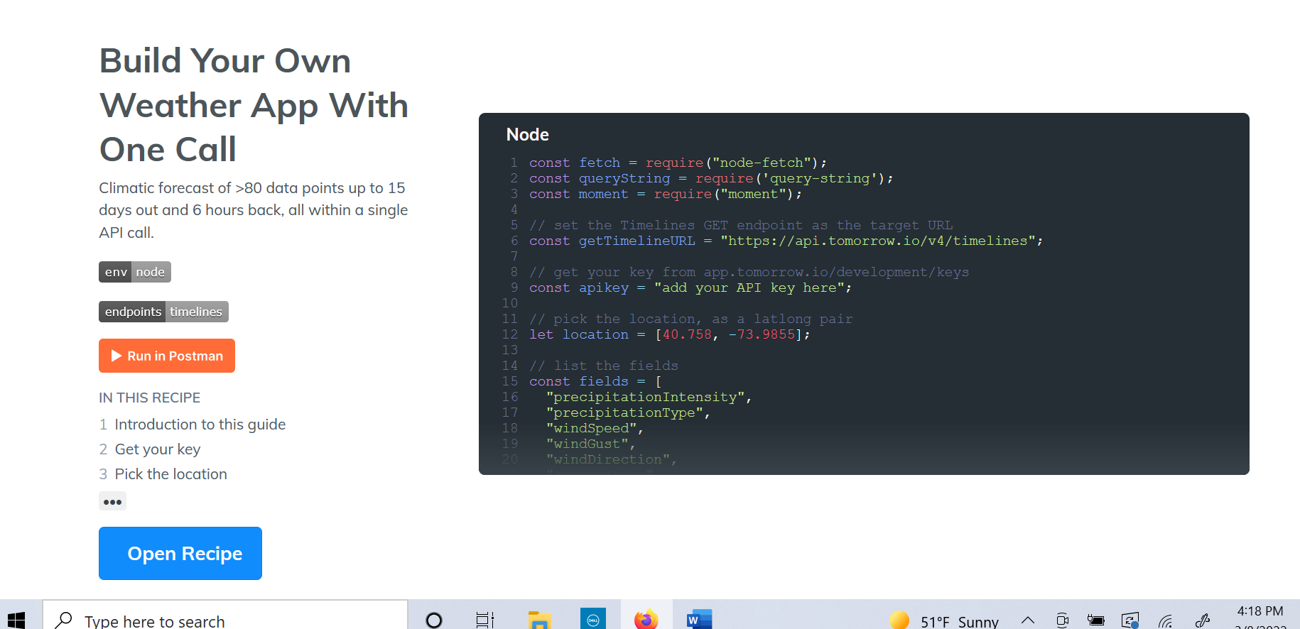

<https://www.tomorrow.io/weather-api/>

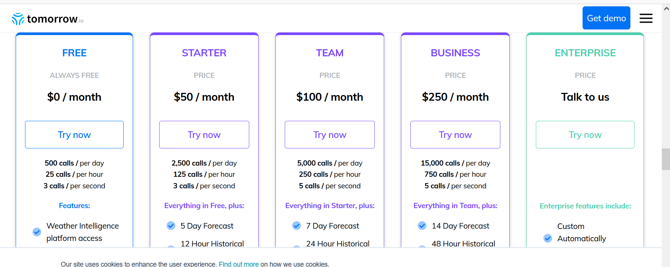

------------------------------------------------------------------------------------------------------------------------------------------

# NOAA National Digital Forecast Database (NDFD)

<https://www.ncei.noaa.gov/products/weather-climate-models/national-digital-forecast-database>

# Has link to link to

# Registry of Open Data on AWS

## [Registry of Open Data on AWS](https://registry.opendata.aws/)

[](http://aws.amazon.com/what-is-cloud-computing)

<https://registry.opendata.aws/noaa-ndfd/>

example they used:

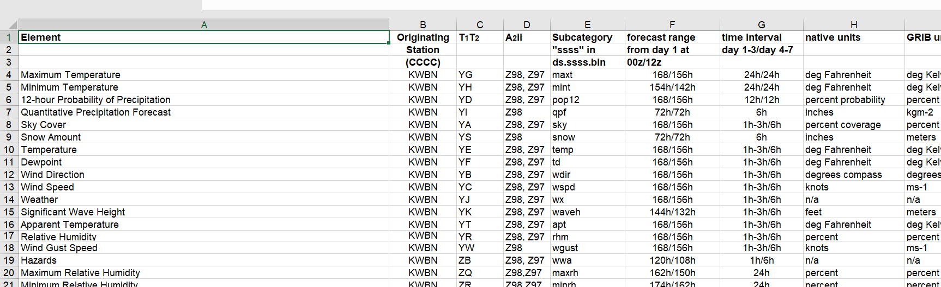

More links to check out for forecast:

<https://www.weather.gov/>

<https://www.weather.gov/search>

<https://search.usa.gov/search?v%3Aproject=firstgov&query=download+data&affiliate=nws.noaa.gov>

<https://www.cpc.ncep.noaa.gov/products/wesley/wgrib2/csv.html>

<https://daac.gsfc.nasa.gov/information/faqs?title=What%20is%20the%20GRIB%20format%3F%20How%20can%20I%20interpret%20it%3F>

<https://search.usa.gov/search?v%3Aproject=firstgov&query=csv&affiliate=nws.noaa.gov>

Find lat long for airports – type in faa code

<https://www.airnav.com/airports/>

------------------------------------------------------------------------------------------------------------------------------------------

**------------------------------------------------------------------------------------------------------------------------------------------**

**Find WGS84 points a certain distance from center (throws error for square and central point option)**

<https://graphical.weather.gov/xml/#use_it>

Note: The square with central point causes an error, but rectangle with corners input works.

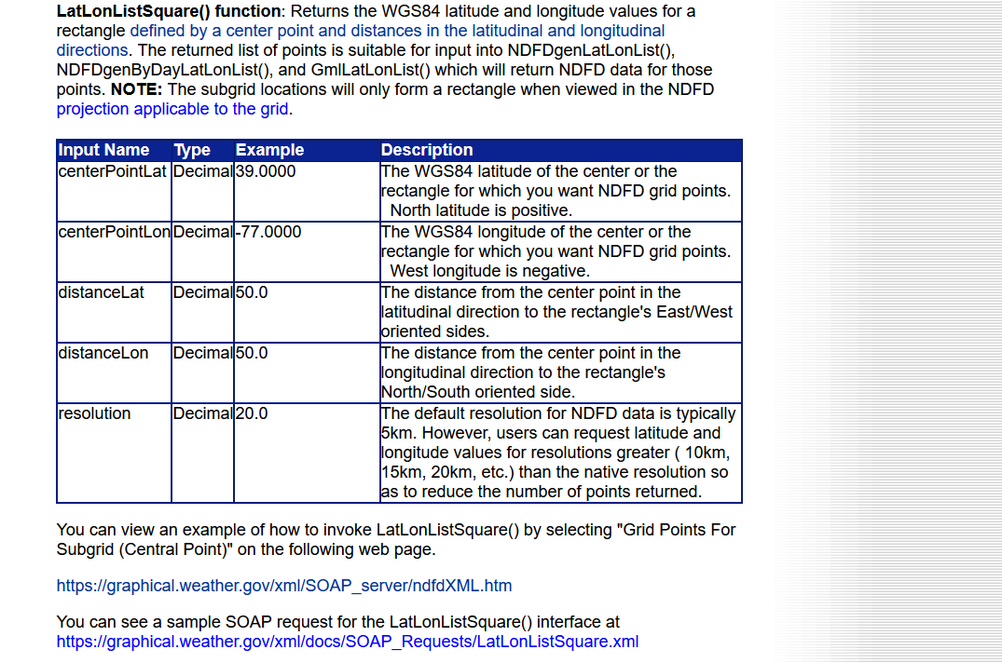

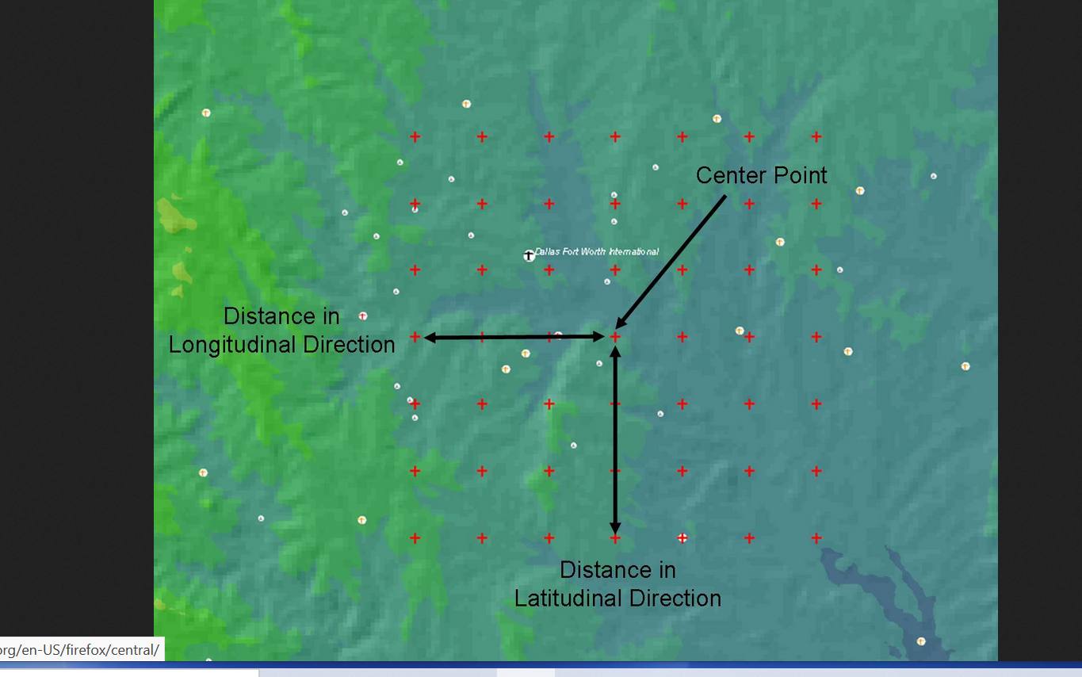

# ****Putting Weather on the Map****

## **The FAA and National Weather Service collaborate to help air traffic controllers better plan operations around bad weather.**

[Putting Weather on the Map. The FAA and National Weather Service… | by Federal Aviation Administration | Cleared for Takeoff | Mar, 2022 | Medium](https://medium.com/faa/putting-weather-on-the-map-82bd2bd995df)

------------------------------------------------------------------------------------------------------------------------------------------------------------------------------------------------------------------------------------------------------------------------------------

WPC Products in Shapefile Format

Weather prediction center in shapefile format

<https://www.wpc.ncep.noaa.gov/html/about_gis.shtml>

Note: Using a circle now with a radius of 50 miles instead of polygon per 3/11/22 meeting

# [Generating polygon representing rough 100km circle around latitude/longitude point using Python?](https://gis.stackexchange.com/questions/268250/generating-polygon-representing-rough-100km-circle-around-latitude-longitude-poi)

https://gis.stackexchange.com/questions/268250/generating-polygon-representing-rough-100km-circle-around-latitude-longitude-poi

**For Fuel Prices**

per 3/11/22 Partner meeting

US Energy Information Administration (EIA)

# SHORT-TERM ENERGY OUTLOOK

[Short-Term Energy Outlook - U.S. Energy Information Administration (EIA)](https://www.eia.gov/outlooks/steo/)

Per 3/11/22 Partner meeting

**FAA’s Aeronautical Delivery Service**

[Federal Aviation Administration - AIS (arcgis.com)](https://adds-faa.opendata.arcgis.com/)

Per 3/11/22 Partner Meeting

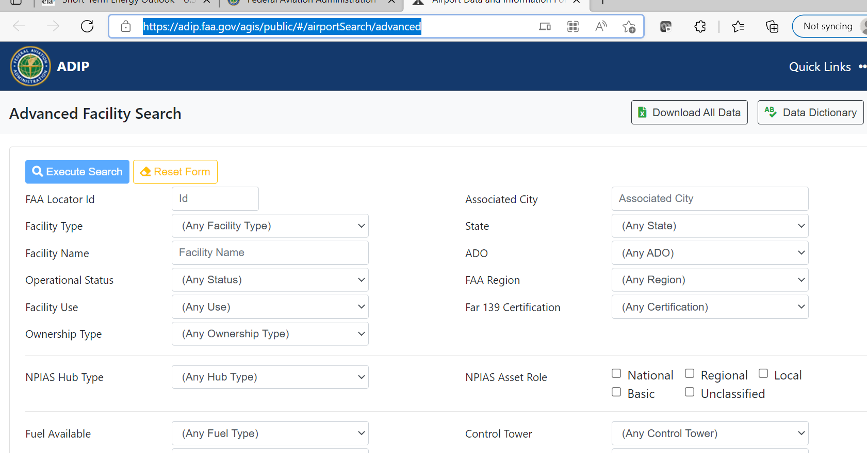

[Airport Data and Information Portal (faa.gov)](https://adip.faa.gov/agis/public/#/airportSearch/advanced)

------------------------------------------------------------------------------------------------------------------------------------------

**How to get python to make API Request**

<https://www.nylas.com/blog/use-python-requests-module-rest-apis/>

# What is a REST API?

Published May 8, 2020 •%t-minute read

Copy URL

## Overview

A REST API (also known as RESTful API) is an application programming interface (API or web API) that conforms to the constraints of REST architectural style and allows for interaction with RESTful web services. REST stands for representational state transfer and was created by computer scientist Roy Fielding

<https://www.nylas.com/blog/use-python-requests-module-rest-apis/>

# How to Use the Python Requests Module With REST APIs

Learn how to use the Python Requests module to interact with any REST API in the world.

**Ben Lloyd Pearson** | **June 11, 2020**

----------------------------------------------------------------------------------------------------------------------------------------